**Questions**

**Q1.**

Two particles, *A* and *B*, have masses 3*m* and 4*m* respectively. The particles are moving towards each other along the same straight line on a smooth horizontal surface. The particles collide directly. Immediately after the collision, *A* and *B* are moving in the same direction with speeds  and *u* respectively. In the collision, *A* receives an impulse of magnitude 8*mu*.

(a)  Find the coefficient of restitution between *A* and *B*.

**(6)**

When *A* and *B* collide they are at a distance *d* from a smooth vertical wall, which is perpendicular to their direction of motion. After the collision with *A*, particle *B* collides directly with the wall and rebounds so that there is a second collision between *A* and *B*. This second collision takes place at distance *x* from the wall.

Given that the coefficient of restitution between *B* and the wall is 

(b)  find *x* in terms of *d*.

**(6)**

**(Total for question = 12 marks)**

**Q2.**

Particles *A*, *B* and *C*, of masses 2*m*, *m* and 3*m* respectively, lie at rest in a straight line on a smooth horizontal plane with *B* between *A* and *C*. Particle *A* is projected towards particle *B* with speed 2*u* and collides directly with *B*.

The coefficient of restitution between each pair of particles is *e*.

(a)  (i)  Show that the speed of *B* immediately after the collision with *A* is *u*(1 + *e*)

(ii)  Find the speed of *A* immediately after the collision with *B*.

**(7)**

At the instant when *A* collides with *B*, particle *C* is projected with speed *u* towards *B* so that *B* and *C* collide directly.

(b)  Show that there will be a second collision between *A* and *B*.

**(6)**

**(Total for question = 13 marks)**

**Q3.**

Particle *P* has mass 4*m* and particle *Q* has mass 2*m*.

The particles are moving in opposite directions along the same straight line on a smooth horizontal surface.

Particle *P* collides directly with particle *Q*.

Immediately **before** the collision, the speed of *P* is 2*u* and the speed of *Q* is 3*u*.

Immediately **after** the collision, the speed of *P* is *x* and the speed of *Q* is *y*.

The direction of motion of each particle is reversed as a result of the collision.

The total kinetic energy of *P* and *Q* after the collision is half of the total kinetic energy of *P* and *Q* before the collision.

(a)  Show that 

**(6)**

The coefficient of restitution between *P* and *Q* is e.

(b)  Find the value of *e*.

**(3)**

After the collision, *Q* hits a smooth fixed vertical wall that is perpendicular to the direction of motion of *Q*.

Particle *Q* rebounds.

The coefficient of restitution between *Q* and the wall is *f*.

Given that there is no second collision between *P* and *Q*,

(c)  find the range of possible values of *f*.

**(3)**

Given that 

(d)  find, in terms of *m* and *u*, the magnitude of the impulse received by *Q* as a result of its impact with the wall.

**(2)**

**(Total for question = 14 marks)**

**Q4.**

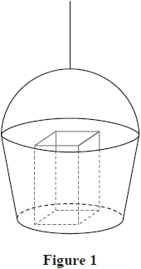

Figure 1 shows a large bucket used by a crane on a building site to move materials between the ground and the top of the building. The mass of the bucket is 15 kg.

The bucket is attached to a vertical cable with the bottom of the bucket horizontal. The cable is modelled as light and inextensible.

When the bucket is on the ground, a bag of cement of mass 25 kg is placed in the bucket.

The bucket with the bag of cement moves vertically upwards with constant acceleration 0.2 ms –2. Air resistance is modelled as being negligible.

(a)  Find the tension in the cable.

**(3)**

At the top of the building, the bag of cement is removed. A box of tools of mass 12 kg is now placed in the bucket.

Later on the bucket with the box of tools is moving vertically downwards with constant deceleration 0.1 ms –2. Air resistance is again modelled as being negligible.

(b)  Find the magnitude of the normal reaction between the bucket and the box of tools

**(3)**

**(Total for question = 6 marks)**

**Q5.**

A car moves along a straight horizontal road with constant acceleration *a* ms –2 where *a* > 0

The car is modelled as a particle.

At time *t* = 0, the car passes point *A* and is moving with speed *u* ms –1

In the first three seconds after passing *A* the car travels 20 m.

In the fourth second after passing *A* the car travels 10 m.

The speed of the car as it passes point *B* is 20 ms –1

Find the time taken for the car to travel from *A* to *B*.

**(Total for question = 8 marks)**

**Q6.**

Two particles, *P* and *Q*, are moving in opposite directions along the same straight line on a smooth horizontal surface so that the particles collide directly.   
The mass of *P* is km and the mass of *Q* is *m*.   
Immediately before the collision, the speed of *P* is *x* and the speed of *Q* is *y*.   
Immediately after the collision, *P* and *Q* are moving in the same direction, the speed of *P* is *v* and the speed of *Q* is 2*v*.

The coefficient of restitution between *P* and *Q* is 

The magnitude of the impulse received by *Q* in the collision is 5 *mv*

(a)  Find (i)  *y* in terms of *v*  
              (ii)  *x* in terms of *v*  
             (iii)  the value of *k*

**(9)**

(b)  Find, in terms of *m* and *v*, the total kinetic energy lost in the collision between *P* and *Q*.

**(3)**

**(Total for question = 12 marks)**

**Q7.**

Two particles, *A* and *B*, are moving in opposite directions along the same straight line on a smooth horizontal surface when they collide directly.   
The mass of *A* is 2*m* and the mass of *B* is 3*m*.

Immediately **after** the collision, *A* and *B* are moving in opposite directions with the same speed *v*.   
In the collision, *A* receives an impulse of magnitude 5*mv*.

(a)  Find the coefficient of restitution between *A* and *B*.

**(6)**

After the collision with *A*, particle *B* strikes a smooth fixed vertical wall and rebounds.   
The wall is perpendicular to the direction of motion of the particles.   
The coefficient of restitution between *B* and the wall is *f*.

As a result of its collision with *A* and with the wall, the total kinetic energy lost by *B* is *E*.   
As a result of its collision with *B*, the kinetic energy lost by *A* is 2*E*.

(b)  Find the value of *f*.

**(4)**

**(Total for question = 10 marks)**

**Q8.**

Two small balls, *A* and *B*, are moving in opposite directions along the same straight line on smooth horizontal ground. The mass of *A* is 2*m* and the mass of *B* is 3*m*.   
The balls collide directly. Immediately before the collision, the speed of *A* is 2*u* and the speed of *B* is *u*. The coefficient of restitution between *A* and *B* is *e*, where *e* > 0

By modelling the balls as particles,

(a)  show that the speed of *B* immediately after the collision is  .

**(6)**

After the collision with ball *A*, ball *B* hits a smooth fixed vertical wall which is perpendicular to the direction of motion of *B*.

The coefficient of restitution between *B* and the wall is 

Ball *B* rebounds from the wall and there is a second direct collision between *A* and *B*.

(b)  Find the range of possible values of *e*.

**(4)**

**(Total for question = 10 marks)**

**Q9.**

A particle *P* of mass 3*m* and a particle *Q* of mass 5*m* are moving towards each other along the same straight line on a smooth horizontal surface. The particles collide directly.

Immediately **before** the collision, the speed of *P* is *u* and the speed of *Q* is *ku*.

Immediately **after** the collision, the speed of *P* is 2*v* and the speed of *Q* is *v*.

The direction of motion of each particle is reversed by the collision.

In the collision, *P* receives an impulse of magnitude 15*mv*.

(a)  Show that *u* = 3*v*.

**(3)**

(b)  Find the value of *k*.

**(3)**

The coefficient of restitution between *P* and *Q* is *e*.

(c)  Find the value of *e*.

**(3)**

The total kinetic energy lost in the collision is λ*mv*2

(d)  Find the value of λ.

**(3)**

**(Total for question = 12 marks)**

**Q10.**

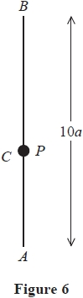

The fixed points, *A* and *B*, are a distance 10*a* apart, with *B* vertically above *A*.

One end of a light elastic string, of natural length 2*a* and modulus of elasticity 2*mg*, is attached to a particle *P* of mass *m* and the other end is attached to *A*.

One end of another light elastic string, of natural length 4*a* and modulus of elasticity 6*mg*, is attached to *P* and the other end is attached to *B*.

The particle *P* rests in equilibrium at the point *C*, as shown in Figure 6.

(a)  Show that each string has an extension of 2*a*.

**(5)**

The particle *P* is now pulled down vertically, so that it is a distance a below *C* and then released from rest.

(b)  Show that in the subsequent motion, *P* performs simple harmonic motion.

**(4)**

(c)  Find, in terms of *a* and *g*, the speed of *P* when it is a distance  above *A*.

**(4)**

**(Total for question = 13 marks)**

**Q11.**

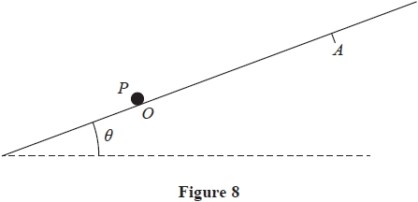

A particle *P* of mass 0.5 kg is attached to one end of a light elastic string of natural length 2 m and modulus of elasticity   
3 N. The other end of the string is attached to a fixed point *O* on a rough plane. The plane is inclined at an angle *θ* to the horizontal,

where sin *θ* = 

The coefficient of friction between *P* and the plane is 

The particle *P* is initially at rest at the point *O*, as shown in Figure 8.

The particle *P* then receives an impulse of magnitude 4 Ns, directed up a line of greatest slope of the plane.

The particle *P* moves up the plane and comes to rest at the point *A*.

(a)  Find the extension of the elastic string when *P* is at *A*.

**(8)**

(b)  Show that the particle does not remain at rest at *A*.

**(3)**

**(Total for question = 11 marks)**

**Q12.**

A particle *P* of mass 0.4 kg is attached to one end of a light elastic string, of natural length 0.8 m and modulus of elasticity 0.6 N. The other end of the string is fixed to a point *A* on a rough horizontal table. The coefficient of friction between *P* and the table is 

The particle *P* is projected from *A*, with speed 1.8 ms–1, along the surface of the table.

After travelling 0.8 m from *A*, the particle passes through the point *B* on the table.

(a)  Find the speed of *P* at the instant it passes through *B*.

**(5)**

The particle *P* comes to rest at the point *C* on the table, where *ABC* is a straight line.

(b)  Find the total distance travelled by *P* as it moves directly from *A* to *C*.

**(6)**

(c)  Show that *P* remains at rest at *C*.

**(3)**

**(Total for question = 14 marks)**

**Q13.**

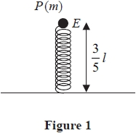

A particle *P* of mass *m* is attached to one end of a light elastic spring of natural length *l* and modulus of elasticity *kmg*, where *k* is a constant. The other end of the spring is fixed to horizontal ground.

The particle *P* rests in equilibrium, with the spring vertical, at the point *E*.

The point *E* is at a height  above the ground, as shown in Figure 1.

(a)  Show that *k* = 

**(2)**

The particle *P* is now moved a distance  vertically downwards from *E* and released from rest. Air resistance is modelled as being negligible.

(b)  Show that *P* moves with simple harmonic motion.

**(4)**

(c)  Find the speed of *P* as it passes through *E*.

**(4)**

(d)  Find the time from the instant *P* is released to the first instant it passes through *E*.

**(2)**

**(Total for question = 12 marks)**

**Q14.**

A light elastic string has natural length 2*a* and modulus of elasticity 2*mg*.

One end of the elastic string is attached to a fixed point *O*. A particle *P* of mass *m* is attached to the other end of the elastic string.

The point *A* is vertically below *O* with *OA* = 4*a*.

Particle *P* is held at *A* and released from rest. The speed of *P* at the instant when it has moved a distance a upwards is 

Air resistance to the motion of *P* is modelled as having magnitude *kmg*, where *k* is a constant.

Using the model and the work-energy principle,

(a)  show that *k* = 

**(7)**

Particle *P* is now held at *O* and released from rest. As *P* moves downwards, it reaches its maximum speed as it passes through the point *B*.

(b)  Find the distance *OB*.

**(4)**

**(Total for question = 11 marks)**

**Q15.**

[*In this question, the unit vectors***i***and***j***are in a vertical plane, with***i***being horizontal and***j***being vertically upwards.*]

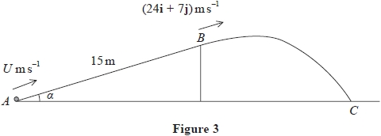

A rough ramp is fixed to horizontal ground.

The ramp is inclined to the ground at an angle *α*, where tan *α* = 

The point *A* is at the bottom of the ramp and the point *B* is at the top of the ramp.

The line *AB* is a line of greatest slope of the ramp and *AB* = 15 m, as shown in Figure 3.

A particle *P* of mass 0.3 kg is projected with speed *U* m s–1 from *A* directly towards *B*.

At the instant *P* reaches the point *B*, the velocity of *P* is (24**i** + 7**j**) m s–1

The particle leaves the ramp at *B*, and moves freely under gravity until it hits the horizontal ground at the point *C*.

The coefficient of friction between *P* and the ramp is 

(a)  Find the work done against friction as *P* moves from *A* to *B*.

**(3)**

(b)  Use the work-energy principle to find the value of *U*.

**(4)**

(c)  Find the time taken by *P* to move from *B* to *C*.

**(3)**

At the instant immediately before *P* hits the ground at *C*, the particle is moving downwards at *θ°* to the horizontal.

(d)  Find the value of *θ*

**(4)**

**(Total for question = 14 marks)**

**Q16.**

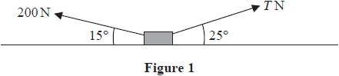

A parcel of mass 20 kg is at rest on a rough horizontal floor. The coefficient of friction between the parcel and the floor is 0.3

Two forces, both acting in the same vertical plane, of magnitudes 200 N and *T* N are applied to the parcel. The line of action of the 200 N force makes an angle of 15° with the horizontal and the line of action of the *T* N force makes an angle of 25° with the horizontal, as shown in Figure 1. The parcel is modelled as a particle *P*.

Find the smallest value of *T* for which *P* remains in equilibrium.

**(Total for question = 9 marks)**

**Q17.**

A particle is acted upon by two forces **F** and **G**. The force **F** has magnitude 8 N and acts in a direction with a bearing of 240°. The force **G** has magnitude 10 N and acts due South.

Given that **R** = **F** + **G**, find

(i)  the magnitude of **R**,

(ii)  the direction of **R**, giving your answer as a bearing to the nearest degree.

**(Total for question = 7 marks)**

**Q18.**

Two girls, Agatha and Brionie, are roller skating inside a large empty building. The girls are modelled as particles.

At time *t* = 0, Agatha is at the point with position vector (11**i** + 11**j**) m and Brionie is at the point with position vector (7**i** + 16**j**) m. The position vectors are given relative to the door, O, and **i** and **j** are horizontal perpendicular unit vectors.

Agatha skates with constant velocity (3**i** – **j**) m s–1

Brionie skates with constant velocity (4**i** – 2**j**) m s–1

(a)  Find the position vector of Agatha at time *t* seconds.

**(2)**

At time *t* = 6 seconds, Agatha passes through the point *P*.

(b)  Show that Brionie also passes through *P* and find the value of *t* when this occurs.

**(4)**

At time *t* seconds, Agatha is at the point *A* and Brionie is at the point *B*.

(c)  Show that  = [(*t* – 4)**i** + (5 – *t*)**j**] m

**(2)**

(d)  Find the distance between the two girls when they are closest together.

**(4)**

**(Total for question = 12 marks)**

**Q19.**

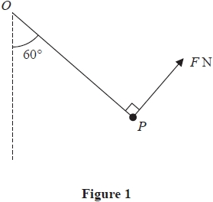

A particle *P* of weight 5 N is attached to one end of a light inextensible string. The other end of the string is attached to a fixed point *O*. The particle *P* is held in equilibrium by a force of magnitude *F* newtons. The direction of this force is perpendicular to the string and *OP* makes an angle of 60° with the vertical, as shown in Figure 1.

Find

(a)  the value of *F*

**(3)**

(b)  the tension in the string.

**(3)**

**(Total for question = 6 marks)**

**Q20.**

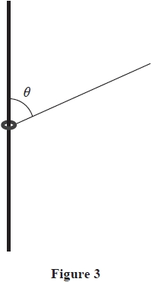

A small ring of mass 0.2 kg is attached to one end of a light inextensible string.

The ring is **threaded** onto a fixed rough vertical rod.

The string is taut and makes an angle *θ* with the rod, as shown in Figure 3, where 

Given that the ring is in equilibrium and that the tension in the string is 10 N,

(a)  find the magnitude of the frictional force acting on the ring,

**(3)**

(b)  state the direction of the frictional force acting on the ring.

**(1)**

The coefficient of friction between the ring and the rod is 

Given that the ring is in equilibrium, and that the tension in the string, *T* newtons, can now vary,

(c)  (i)  find the minimum value of *T*

(ii)  find the maximum value of *T*

**(8)**

**(Total for question = 12 marks)**

**Q21.**

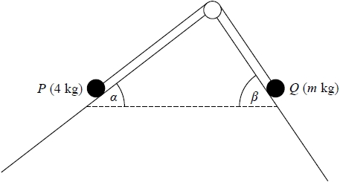

**Figure 3**

A particle *P* of mass 4 kg is attached to one end of a light inextensible string. A particle *Q* of mass *m* kg is attached to the other end of the string. The string passes over a small smooth pulley which is fixed at a point on the intersection of two fixed inclined planes. The string lies in a vertical plane that contains a line of greatest slope of each of the two inclined planes. The first plane is inclined to the horizontal at an angle *α*, where tan *α* =  and the second plane is inclined to the horizontal at an angle *β*, where tan *β* = . Particle *P* is on the first plane and particle *Q* is on the second plane with the string taut, as shown in Figure 3.

The first plane is rough and the coefficient of friction between *P* and the plane is . The second plane is smooth. The system is in limiting equilibrium.

Given that *P* is on the point of slipping down the first plane,

(a)  find the value of *m*,

**(10)**

(b)  find the magnitude of the force exerted on the pulley by the string,

**(4)**

(c)  find the direction of the force exerted on the pulley by the string.

**(1)**

**(Total for question = 15 marks)**

**Q22.**

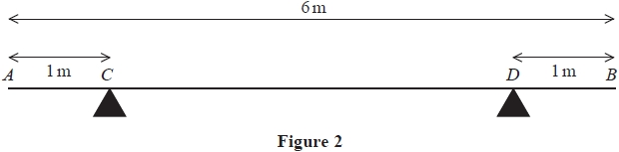

A metal girder *AB* has weight *W* newtons and length 6 m. The girder rests in a horizontal position on two supports *C* and *D* where *AC* = *DB* = 1 m, as shown in Figure 2.

When a force of magnitude 900 N is applied vertically upwards to the girder at *A*, the girder is about to tilt about *D*.

When a force of magnitude 1500 N is applied vertically upwards to the girder at *B*, the girder is about to tilt about *C*.

The girder is modelled as a non-uniform rod whose centre of mass is a distance *x* metres from *A*.

Find the value of *x*.

**(Total for question = 6 marks)**

**Q23.**

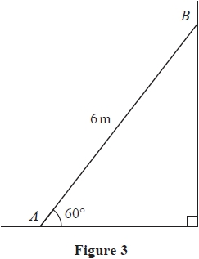

A ladder *AB* has length 6 m and mass 30 kg. The ladder rests in equilibrium at 60° to the horizontal with the end *A* on rough horizontal ground and the end *B* against a smooth vertical wall, as shown in Figure 3.

A man of mass 70 kg stands on the ladder at the point *C*, where *AC* = 2 m, and the ladder remains in equilibrium. The ladder is modelled as a uniform rod in a vertical plane perpendicular to the wall. The man is modelled as a particle.

(a)  Find the magnitude of the force exerted on the ladder by the ground.

**(6)**

The man climbs further up the ladder. When he is at the point *D* on the ladder, the ladder is about to slip.

Given that the coefficient of friction between the ladder and the ground is 0.4

(b)  find the distance *AD*.

**(4)**

(c)  State how you have used the modelling assumption that the ladder is a rod.

**(1)**

**(Total for question = 11 marks)**

**Q24.**

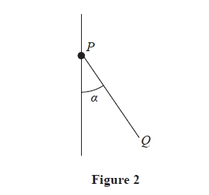

A small bead of mass 0.2 kg is attached to the end *P* of a light rod *PQ*. The bead is threaded onto a fixed vertical rough wire.

The bead is held in equilibrium with the rod *PQ* inclined to the wire at an angle *α*, where tan *α* =, as shown in Figure 2.

The thrust in the rod is *T* newtons.

The bead is modelled as a particle.

(a)  Find the magnitude and direction of the friction force acting on the bead when *T* = 2.5

**(3)**

The coefficient of friction between the bead and the wire is *μ*.

Given that the greatest possible value of *T* is 6.125

(b)  find the value of *μ*.

**(7)**

**(Total for question = 10 marks)**

**Q25.**

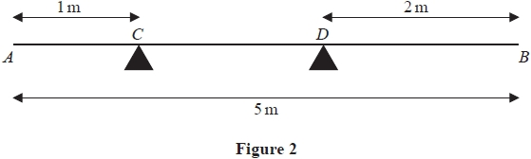

A uniform rod *AB* has length 5 m and mass 5 kg. The rod rests in equilibrium in a horizontal position on two supports *C* and *D*, where *AC* = 1 m and *DB* = 2 m , as shown in Figure 2.

A particle of mass 10 kg is placed on the rod at *A* and a particle of mass *M* kg is placed on the rod at *B*. The rod remains horizontal and in equilibrium.

(a)  Find, in terms of *M*, the magnitude of the reaction on the rod at *C*.

**(3)**

(b)  Find, in terms of *M*, the magnitude of the reaction on the rod at *D*.

**(3)**

(c)  Hence, or otherwise, find the range of possible values of *M*.

**(3)**

**(Total for question = 9 marks)**

**Q26.**

[*In this question***i** and **j***are perpendicular horizontal unit vectors*.]

Three forces, **F**1, **F**2 and **F**3, are given by

**F**1 = (5**i** + 2**j**) N          **F**2 = (–3**i** + **j**) N          **F**3 = (*a***i** + *b***j**) N

where *a* and *b* are constants.

The forces **F**1, **F**2 and **F**3 act on a particle *P* of mass 4 kg.

Given that *P* rests in equilibrium on a smooth horizontal surface under the action of these three forces,

(a)  find the size of the angle between the direction of **F**3 and the direction of – **j**.

**(4)**

The force **F**3 is now removed and replaced by the force **F**4 given by **F**4 = *λ* (**i** + 3**j**) N, where *λ* is a positive constant.

When the three forces **F**1, **F**2 and **F**4 act on *P*, the acceleration of *P* has magnitude 3.25 ms –2

(b)  Find the value of *λ*.

**(5)**

**(Total for question = 9 marks)**

**Q27.**

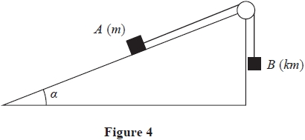

Figure 4 shows a block *A* of mass *m* held at rest on a rough plane.   
The plane is inclined at an angle *α* to the horizontal and the coefficient of friction between the block and the plane is *μ*.

One end of a light inextensible string is now attached to *A*. The string passes over a small smooth pulley which is fixed at the top of the plane.   
The other end of the string is attached to a block *B* of mass *km*.   
Block *B* hangs vertically below the pulley, with the string taut.

The string from *A* to the pulley lies along a line of greatest slope of the plane.

Both *A* and *B* are modelled as particles.

When the system is released from rest, A moves up the plane and the tension in the string is 

Given that 

(a)  (i)  find the magnitude of the acceleration of *A*, giving your answer in terms of *g*,

(ii)  find the value of *k*.

**(9)**

(b)  Find the magnitude of the resultant force exerted on the pulley by the string, giving your answer in terms of *m* and *g*.

**(4)**

**(Total for question = 13 marks)**

**Q28.**

*[In this question* ***i*** *and* ***j*** *are horizontal perpendicular unit vectors.]*

A particle *P* rests in equilibrium on a smooth horizontal plane.

A system of **three** forces, **F**1 N, **F**2 N and **F**3 N where

**F**1 = (3*c***i** + 4*c***j**)

**F**2 = (-14**i** + 7**j**)

is applied to *P*.

Given that *P* remains in equilibrium,

(a)  find **F**3 in terms of *c*, **i** and **j**.

**(2)**

The force **F**3 is removed from the system.

Given that *c* = 2

(b)  find the size of the angle between the direction of **i** and the direction of the resultant force acting on *P*.

**(4)**

The mass of *P* is *m* kg.

Given that the magnitude of the acceleration of *P* is 8.5 m s-2

(c)  find the value of *m*.

**(4)**

**(Total for question = 10 marks)**

**Q29.**

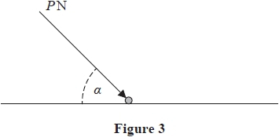

A particle of weight *W* newtons lies at rest on a rough horizontal surface, as shown in Figure 3.

A force of magnitude *P* newtons is applied to the particle.

The force acts at an angle *α* to the horizontal, where 

The coefficient of friction between the particle and the surface is 

Given that the particle does not move, show that



**(Total for question = 7 marks)**

**Q30.**

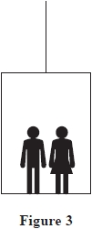

Two children, Alan and Bhavana, are standing on the horizontal floor of a lift, as shown in Figure 3.

The lift has mass 250 kg. The lift is raised vertically upwards with constant acceleration by a vertical cable which is attached to the top of the lift. The cable is modelled as being light and inextensible. While the lift is accelerating upwards, the tension in the cable is 3616 N.

As the lift accelerates upwards, the floor of the lift exerts a force of magnitude 565 N on Alan and a force of magnitude 226 N on Bhavana.

Air resistance is modelled as being negligible and Alan and Bhavana are modelled as particles.

(a)  By considering the forces acting on the lift only, find the acceleration of the lift.

**(3)**

(b)  Find the mass of Alan.

**(3)**

**(Total for question = 6 marks)**

**Q31.**

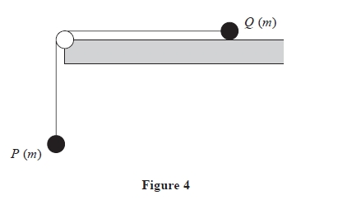

A particle *P* of mass *m* is attached to one end of a light inextensible string. Another particle *Q*, also of mass *m*, is attached to the other end of the string. The string passes over a small smooth pulley which is fixed at the edge of a rough horizontal table. Particle *Q* is held at rest on the table and particle *P* hangs vertically below the pulley with the string taut, as shown in Figure 4.

The pulley, *P* and *Q* all lie in the same vertical plane.

The coefficient of friction between *Q* and the table is *μ*, where *μ* < 1

Particle *Q* is released from rest.

The tension in the string before *Q* hits the pulley is kmg, where *k* is a constant.

(a)  Find *k* in terms of *μ*.

**(7)**

Given that *Q* is initially a distance *d* from the pulley,

(b)  find, in terms of *d*, *g* and *μ*, the time taken by *Q*, after release, to reach the pulley.

**(4)**

(c)  Describe what would happen if *μ* ≥ 1, giving a reason for your answer.

**(2)**

**(Total for question = 13 marks)**

**Q32.**

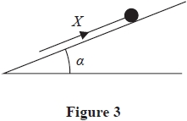

A particle of mass *m* rests in equilibrium on a fixed rough plane under the action of a force of magnitude *X*. The force acts up a line of greatest slope of the plane, as shown in Figure 3.

The plane is inclined at an angle *α* to the horizontal, where 

The coefficient of friction between the particle and the plane is *μ*.

• When *X* = 2*P*, the particle is on the point of sliding up the plane.  
• When *X* = *P*, the particle is on the point of sliding down the plane.

Find the value of *μ*.

**(Total for question = 8 marks)**

**Q33.**

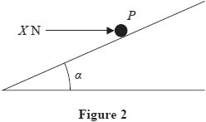

A rough plane is inclined to the horizontal at an angle α, where tan α = 3/4

A particle *P* of mass 2 kg is held in equilibrium on the plane by a horizontal force of magnitude *X* newtons, as shown in Figure 2. The force acts in a vertical plane which contains a line of greatest slope of the inclined plane.

(a)  Show that when *X* = 14.7 there is no frictional force acting on *P*

**(3)**

The coefficient of friction between *P* and the plane is 0.5

(b)  Find the smallest possible value of *X*.

**(8)**

**(Total for question = 11 marks)**

**Q34.**

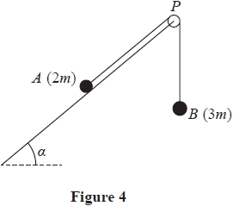

One end of a light inextensible string is attached to a particle *A* of mass 2*m*. The other end of the string is attached to a particle *B* of mass 3*m*. The string passes over a small, smooth, light pulley *P* which is fixed at the top of a rough inclined plane. The plane is inclined to the horizontal at an angle *α*, where tan *α* = 

Particle *A* is held at rest on the plane with the string taut and *B* hanging freely below *P*, as shown in Figure 4. The section of the string *AP* is parallel to a line of greatest slope of the plane.

The coefficient of friction between *A* and the plane is 

Particle *A* is released and begins to move up the plane.

For the motion before *A* reaches the pulley,

(a)  (i)  write down an equation of motion for *A*,

(ii)  write down an equation of motion for *B*,

**(4)**

(b)  find, in terms of *g*, the acceleration of *A*,

**(5)**

(c)  find the magnitude of the force exerted on the pulley by the string.

**(4)**

(d)  State how you have used the information that *P* is a smooth pulley.

**(1)**

**(Total for question = 14 marks)**

**Q35.**

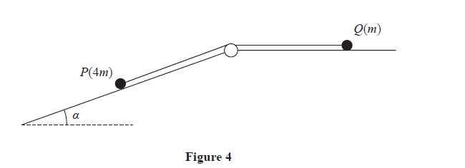

A particle *P* of mass 4*m* lies on the surface of a fixed rough inclined plane.

The plane is inclined to the horizontal at an angle *α* where 

The particle *P* is attached to one end of a light inextensible string.

The string passes over a small smooth pulley that is fixed at the top of the plane. The other end of the string is attached to a particle *Q* of mass *m* which lies on a smooth horizontal plane.

The string lies along the horizontal plane and in the vertical plane that contains the pulley and a line of greatest slope of the inclined plane.

The system is released from rest with the string taut, as shown in Figure 4, and *P* moves down the plane.

The coefficient of friction between *P* and the plane is 

For the motion before *Q* reaches the pulley

(a)  write down an equation of motion for *Q*,

**(1)**

(b)  find, in terms of *m* and *g*, the tension in the string,

**(7)**

(c)  find the magnitude of the force exerted on the pulley by the string.

**(4)**

(d)  State where in your working you have used the information that the string is light.

**(1)**

**(Total for question = 13 marks)**

**Q36.**

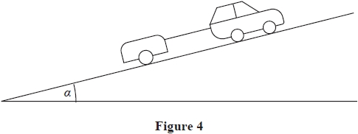

A car of mass 1200 kg is towing a trailer of mass 600 kg up a straight road, as shown in Figure 4.

The road is inclined at an angle α to the horizontal, where 

The driving force produced by the engine of the car is 3000 N.

The car moves with acceleration 0.75 m s-2

The non-gravitational resistance to motion of

• the **car** is modelled as a constant force of magnitude 2*R* newtons  
• the **trailer** is modelled as a constant force of magnitude *R* newtons

The car and the trailer are modelled as particles.

The tow bar between the car and trailer is modelled as a light rod that is parallel to the direction of motion.

Using the model,

(a)  show that the value of *R* is 60

**(4)**

(b)  find the tension in the tow bar.

**(3)**

When the car and trailer are moving at a speed of 12 m s-1 , the tow bar breaks.

Given that the non-gravitational resistance to motion of the trailer remains unchanged,

(c)  use the model to find the further distance moved by the trailer before it first comes to rest.

**(4)**

**(Total for question = 11 marks)**

**Q37.**

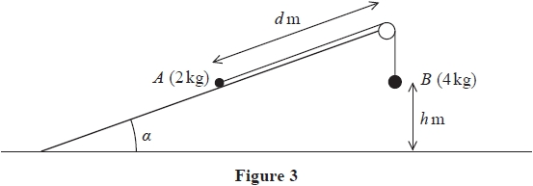

Two particles, *A* and *B*, have masses 2 kg and 4 kg respectively. The particles are connected by a light inextensible string. The string passes over a small smooth pulley which is fixed at the top of a rough plane. The plane is inclined to the horizontal ground at an angle *α* where tan *α* = . The particle *A* is held at rest on the plane at a distance *d* metres from the pulley. The particle *B* hangs freely at rest, vertically below the pulley, at a distance *h* metres above the ground, as shown in Figure 3. The part of the string between *A* and the pulley is parallel to a line of greatest slope of the plane. The coefficient of friction between *A* and the plane is .

The system is released from rest with the string taut and *B* descends.

(a)  Find the tension in the string as *B* descends.

**(9)**

On hitting the ground, *B* immediately comes to rest.

Given that *A* comes to rest before reaching the pulley,

(b)  find, in terms of *h*, the range of possible values of *d*.

**(7)**

(c)  State one physical factor, other than air resistance, that could be taken into account to make the model described above   
       more realistic.

**(1)**

**(Total for question = 17 marks)**

**Q38.**

A tractor of mass 6 tonnes is dragging a large block of mass 2 tonnes along rough horizontal ground. The cable connecting the tractor to the block is horizontal and parallel to the direction of motion.

The cable is modelled as being light and inextensible.

The driving force of the tractor is 7400 N and the resistance to the motion of the tractor is 200 N. The resistance to the motion of the block is *R* newtons, where *R* is a constant.

Given that the tension in the cable is 6000 N and the tractor is accelerating,

(a)  find the value of *R*.

**(6)**

(b)  State how you have used the fact that the cable is modelled as being inextensible.

**(1)**

**(Total for question = 7 marks)**

**Q39.**

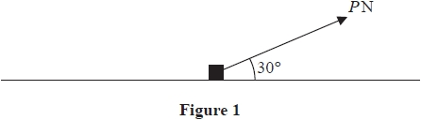

A small block of mass 5 kg lies at rest on a rough horizontal plane.

The coefficient of friction between the block and the plane is 

A force of magnitude *P* newtons is applied to the block in a direction which makes an angle of 30° with the plane, as shown in Figure 1.

The block is modelled as a particle.

Given that *P* = 14

(a)  find the magnitude of the frictional force exerted on the block by the plane and describe what happens to the block, justifying your answer.

**(6)**

The value of *P* is now changed so that the block is on the point of slipping along the plane.

(b)  Find the value of *P*

**(6)**

**(Total for question = 12 marks)**

**Q40.**

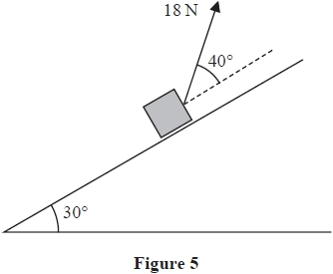

A parcel of mass 2 kg is pulled up a rough inclined plane by the action of a constant force.

The force has magnitude 18 N and acts at an angle of 40° to the plane.

The line of action of the force lies in a vertical plane containing a line of greatest slope of the inclined plane.

The plane is inclined at an angle of 30° to the horizontal, as shown in Figure 5.

The coefficient of friction between the plane and the parcel is 0.3

The parcel is modelled as a particle *P*

(a)  Find the acceleration of *P*

**(8)**

The points *A* and *B* lie on a line of greatest slope of the plane, where *AB* = 5 m and *B* is above *A*. Particle *P* passes through *A* with speed 2 m s−1 in the direction *AB*.

(b)  Find the speed of *P* as it passes through *B*.

**(3)**

The force of 18 N is removed at the instant *P* passes through *B*. As a result, *P* comes to rest at the point *C*.

(c)  Determine whether *P* will remain at rest at *C*. You must show all stages of your working clearly.

**(4)**

**(Total for question = 15 marks)**

**Q41.**

Particle *P* has mass 3*m* and particle *Q* has mass *km*. The particles are moving towards each other on the same straight line on a smooth horizontal surface.   
The particles collide directly.   
Immediately **before** the collision, the speed of *P* is 2*u* and the speed of *Q* is 3*u*.   
Immediately **after** the collision, the speed of *P* is *u* and the speed of *Q* is *v*.

(a)  Show that 

**(3)**

(b)  Find, in terms of *m* and *u*, the magnitude of the impulse received by *Q* in the collision.

**(2)**

The coefficient of restitution between *P* and *Q* is *e*.

Given that *v* ≠ *u*

(c)  find the range of possible values of *k*.

**(5)**

**(Total for question = 10 marks)**

**Q42.**

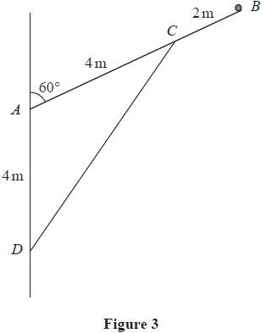

A uniform pole *AB*, of weight 50 N and length 6 m, has a particle of weight *W* newtons attached at its end *B*. The pole has its end *A* freely hinged to a vertical wall.   
A light rod holds the particle and pole in equilibrium with the pole at 60° to the wall.   
One end of the light rod is attached to the pole at *C*, where *AC* = 4 m.   
The other end of the light rod is attached to the wall at the point *D*.   
The point *D* is vertically below *A* with *AD* = 4 m, as shown in Figure 3.

The pole and the light rod lie in a vertical plane which is perpendicular to the wall.

The pole is modelled as a rod.

Given that the thrust in the light rod is ,

(a)  show that *W* = 15

**(4)**

(b)  find the magnitude of the resultant force acting on the pole at *A*.

**(6)**

**(Total for question = 10 marks)**

**Q43.**

A particle *P* of mass 0.5 kg is moving with velocity (5**i** + 3**j**) m s–1

The particle receives an impulse (–2**i** + *λ***j**) N s , where λ is a constant.

Immediately after receiving the impulse, the velocity of *P* is (x**i** + y**j**) m s–1

The kinetic energy gained by *P* as a result of receiving the impulse is 22 J.

Find the possible values of *λ*.

**(Total for question = 7 marks)**

**Q44.**

Two particles, *A* and *B*, are moving in a straight line in opposite directions towards each other on a smooth horizontal surface when they collide directly.

Particle *A* has mass 3*m* kg and particle *B* has mass *m* kg.

Immediately before the collision, both particles have a speed of 1.5 m s−1

Immediately after the collision, the direction of motion of *A* is unchanged and the difference between the speed of *A* and speed of *B* is 1 *m s−1*

(a)  Find (i)  the speed of *A* immediately after the collision,

(ii)  the speed of *B* immediately after the collision.

**(5)**

(b)  Find, in terms of *m*, the magnitude of the impulse exerted on *B* in the collision.

**(3)**

**(Total for question = 8 marks)**

**Q45.**

A truck of mass 1500 kg is moving on a straight horizontal road.   
The engine of the truck is working at a constant rate of 30 kW.   
The resistance to the motion of the truck is modelled as a constant force of magnitude *R* newtons.   
At the instant when the truck is moving at a speed of 20 m s–1, the acceleration of the truck is 0.6 m s–2

(a)  Find the value of *R*.

**(4)**

Later on, the truck is moving up a straight road that is inclined at an angle *α* to the horizontal, where 

The resistance to the motion of the truck from non-gravitational forces is modelled as a constant force of magnitude 500 N.   
The engine of the truck is again working at a constant rate of 30 kW.   
At the instant when the speed of the truck is *V* m s–1 , the deceleration of the truck is 0.2 m s–2

(b)  Find the value of *V*

**(4)**

**(Total for question = 8 marks)**

**Q46.**

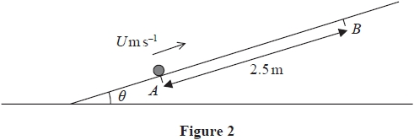

A rough straight ramp is fixed to horizontal ground. The ramp is inclined at an angle *θ* to the horizontal, where 

The points *A* and *B* are on a line of greatest slope of the ramp, with *AB* = 2.5 m and *B* above *A*, as shown in Figure 2.

A package of mass 1.5 kg is projected up the ramp from *A* with speed *U* m s–1 and first comes to instantaneous rest at *B*.

The coefficient of friction between the package and the ramp is 

The package is modelled as a particle.

(a)  Find the work done against friction as the package moves from *A* to *B*.

**(3)**

(b)  Use the work–energy principle to find the value of *U*.

**(4)**

After coming to instantaneous rest at *B*, the package slides back down the slope.

(c)  Use the work–energy principle to find the speed of the package at the instant it returns to *A*.

**(3)**

**(Total for question = 10 marks)**

**Q47.**

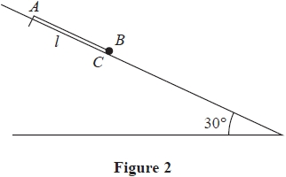

One end of a light elastic string, of natural length *l* and modulus of elasticity *λ*, is fixed to a point *A* on a smooth plane. The plane is inclined at 30° to the horizontal.

A small ball *B* of mass *m* is attached to the other end of the elastic string. Initially, *B* is held at rest at the point *C* on the plane with the elastic string lying along a line of greatest slope of the plane.

The point *C* is below *A* and *AC* = *l*, as shown in Figure 2.

The ball is released and comes to instantaneous rest at a point *D* on the plane.

The points *A*, *C* and *D* all lie along a line of greatest slope of the plane and *AD* = 

The ball is modelled as a particle and air resistance is modelled as being negligible.

Using the model,

(a)  show that *λ* = 4*mg*

**(4)**

(b)  find, in terms of *g* and *l*, the greatest speed of *B* as it moves from *C* to *D*

**(7)**

**(Total for question = 11 marks)**

**Q48.**

Particle *A* has mass *m* and particle *B* has mass 2*m*.

The particles are moving in the same direction along the same straight line on a smooth horizontal surface.

Particle *A* collides directly with particle *B*.

Immediately before the collision, the speed of *A* is 3*u* and the speed of *B* is *u*.

The coefficient of restitution between *A* and *B* is *e*.

(a)  (i)  Show that the speed of *B* immediately after the collision is 

(ii)  Find the speed of *A* immediately after the collision.

**(7)**

After the collision, *B* hits a smooth fixed vertical wall that is perpendicular to the direction of motion of *B*.

The coefficient of restitution between *B* and the wall is 

Particle B rebounds and there is a second collision between *A* and *B*.

The first collision between *A* and *B* occurs at a distance *d* from the wall. The time between the two collisions is *T*.

Given that 

(b)  find *T* in terms of *d* and *u*.

**(6)**

**(Total for question = 13 marks)**

**Q49.**

A particle *P* of mass 0.2 kg is moving with velocity (4**i** – 3**j**) m s–1

The particle receives an impulse *λ*(**i** + **j**) N *s*, where *λ* is a constant.

Immediately after receiving the impulse, the speed of *P* is 7 m s–1

Find the possible values of *λ*

**(6)**

**(Total for question = 6 marks)**

**Q50.**

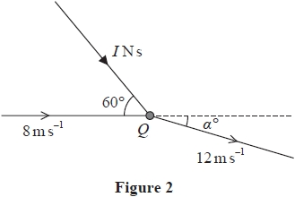

A particle *Q* of mass 0.25 kg is moving in a straight line on a smooth horizontal surface with speed 8 m s−1 when it receives an impulse of magnitude *I* N s.

The impulse acts parallel to the horizontal surface and at 60° to the original direction of motion of *Q*.

Immediately after receiving the impulse, the speed of *Q* is 12 m s−1

As a result of receiving the impulse, the direction of motion of *Q* is turned through α°, as shown in Figure 2.

Find the value of *I*

**(Total for question = 6 marks)**

**Q51.**

A particle *P* of mass 0.3 kg is moving with velocity 5**i** ms-1

The particle receives an impulse **I** Ns.

Immediately after receiving the impulse, the velocity of *P* is (7**i** + 7**j**)ms-1

(a)  Find the magnitude of **I**

**(4)**

(b)  Find the angle between the direction of **I** and the direction of motion of *P* immediately before receiving the impulse.

**(3)**

**(Total for question = 7 marks)**

**Q52.**

A particle *P* of mass 0.75 kg is moving with velocity 4**i** m s–1 when it receives an impulse **J** Ns. Immediately after *P* receives the impulse, the speed of *P* is 8 m s–1

Given that **J** = *c*(–**i** + 2**j**), where *c* is a constant, find the two possible values of *c*.

**(6)**

**(Total for question = 6 marks)**

**Q53.**

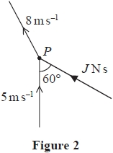

A particle *P* of mass 0.3 kg is moving with speed 5 ms–1 along a straight line on a smooth horizontal plane. The particle receives a horizontal impulse of magnitude *J* N s. The speed of *P* immediately after receiving the impulse is 8 ms–1. The angle between the direction of motion of *P* before it receives the impulse and the direction of the impulse is 60°, as shown in Figure 2.

Find the value of *J*.

**(Total for question = 6 marks)**

**Q54.**

A particle *P* of mass 0.5 kg is moving with velocity *λ*(**i** + **j**) m s–1 when *P* receives an impulse of magnitude  N s

Immediately after *P* receives the impulse, the velocity of *P* is 4**i** m s–1  
Given that *λ* is a constant, find the two possible values of *λ*

**(Total for question = 6 marks)**

**Q55.**

A particle *P* of mass 1.5 kg is moving with velocity (4**i** + 6**j**) m s–1 when it receives an impulse of magnitude 15 Ns. Immediately after *P* receives the impulse, the velocity of *P* is *v***i** m s–1.

Find the two possible values of *v*.

**(Total for question = 7 marks)**

**Q56.**

A particle of mass 0.5 kg is moving with velocity (2**i** + 4**j**)m s−1 when it receives an impulse of (−4**i** + 6**j**)N s.

(a)  Find the speed of the particle immediately after it receives the impulse.

**(5)**

(b)  Find the size of the angle between the direction of motion of the particle immediately before it receives the impulse and the direction of motion of the particle immediately after it receives the impulse.

**(3)**

**(Total for question = 8 marks)**

**Q57.**

Two small children, Ajaz and Beth, are running a 100 m race along a straight horizontal track.

They both start from rest, leaving the start line at the same time.

Ajaz accelerates at 0.8 m s–2 up to a speed of 4 m s–1 and then maintains this speed until he crosses the finish line.

Beth accelerates at 1 m s–2 for *T* seconds and then maintains a constant speed until she crosses the finish line.

Ajaz and Beth cross the finish line at the same time.

(a)  Sketch, on the same axes, a speed-time graph for each child, from the instant when they leave the start line to the instant when they cross the finish line.

**(3)**

(b)  Find the time taken by Ajaz to complete the race.

**(4)**

(c)  Find the value of *T*

**(4)**

(d)  Find the difference in the speeds of the two children as they cross the finish line.

**(2)**

**(Total for question = 13 marks)**

**Q58.**

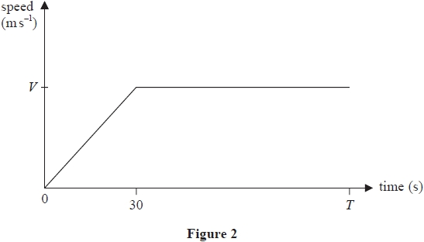

The speed-time graph in Figure 2 illustrates the motion of a car travelling along a straight horizontal road.

At time *t* = 0 , the car starts from rest and accelerates uniformly for 30 s until it reaches a speed of *V* m s-1

The car then travels at a constant speed of *V* m s-1 until time *t* = *T* seconds.

(a)  Show that the distance travelled by the car between *t* = 0 and *t* = *T* seconds is *V*(*T* - 15) metres.

**(2)**

A motorbike also travels along the same road.

• The motorbike starts from rest at time ***t* = 10 s** and accelerates uniformly for 40 s  
• The acceleration of the motorbike is the **same** as the acceleration of the car  
• The motorbike then travels at a constant speed for a further 10 s before decelerating uniformly until it reaches a speed of *V* m s-1 at time *T* seconds

(b)  On Figure 2, sketch a speed-time graph for the motion of the motorbike.

*[If you need to redraw your sketch, there is a copy of Figure 2.]*

**(2)**

(c)  Show that the constant speed of the motorbike is 

**(2)**

At time *t* = *T* seconds, the distance travelled by each vehicle is the same.

(d)  Find the value of *T*

**(5)**

**Only use this copy of Figure 2 if you need to redraw your sketch.**

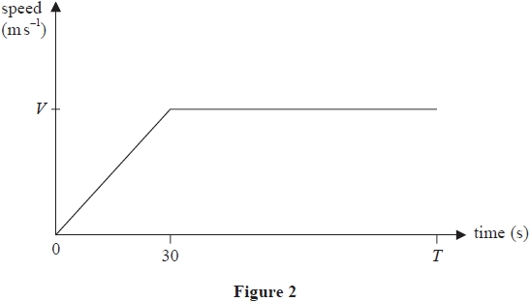

**(Total for question = 11 marks)**

**Q59.**

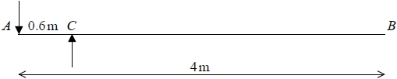

**Figure 1**

A diving board *AB* consists of a wooden plank of length 4m and mass 30kg. The plank is held at rest in a horizontal position by two supports at the points *A* and *C*, where *AC* = 0.6 m, as shown in Figure 1. The force on the plank at *A* acts vertically downwards and the force on the plank at *C* acts vertically upwards.

A diver of mass 50 kg is standing on the board at the end *B*. The diver is modelled as a particle and the plank is modelled as a uniform rod. The plank is in equilibrium.

(a)  Find

(i)  the magnitude of the force acting on the plank at *A*,

(ii)  the magnitude of the force acting on the plank at *C*.

**(6)**

The support at *A* will break if subjected to a force whose magnitude is greater than 5000 N.

(b)  Find, in kg, the greatest integer mass of a diver who can stand on the board at *B* without breaking the support at *A*.

**(3)**

(c)  Explain how you have used the fact that the diver is modelled as a particle.

**(1)**

**(Total for question = 10 marks)**

**Q60.**

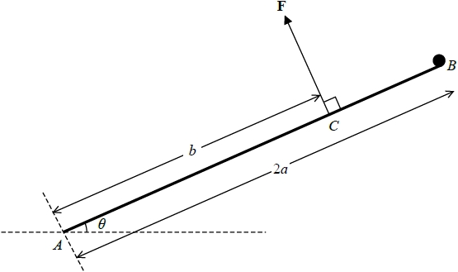

**Figure 3**

A uniform rod *AB*, of mass 3*m* and length 2*a*, is freely hinged at *A* to a fixed point on horizontal ground. A particle of mass *m* is attached to the rod at the end *B*. The system is held in equilibrium by a force **F** acting at the point *C*, where *AC* = *b*. The rod makes an acute angle *θ* with the ground, as shown in Figure 3. The line of action of **F** is perpendicular to the rod and in the same vertical plane as the rod.

(a)  Show that the magnitude of 

**(4)**

The force exerted on the rod by the hinge at *A* is **R**, which acts upwards at an angle  above the horizontal, where  > *θ*.

(b)  Find

(i)  the component of **R** parallel to the rod, in terms of *m*, *g* and *θ*,

(ii)  the component of **R** perpendicular to the rod, in terms of *a*, *b*, *m*, *g* and *θ*.

**(5)**

(c)  Hence, or otherwise, find the range of possible values of *b*, giving your answer in terms of *a*.

**(2)**

**(Total for question = 11 marks)**

**Q61.**

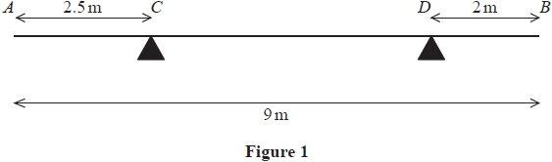

A non-uniform rod *AB* has length 9 m and mass *M* kg.

The rod rests in equilibrium in a horizontal position on two supports, one at *C* where *AC* = 2.5 m and the other at *D* where *DB* = 2 m, as shown in Figure 1.

The magnitude of the force acting on the rod at *D* is twice the magnitude of the force acting on the rod at *C*.

The centre of mass of the rod is *d* metres from *A*.

Find the value of *d*.

**(6)**

**(Total for question = 6 marks)**

**Q62.**

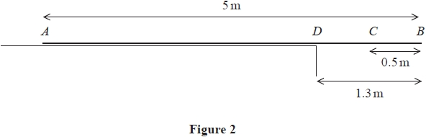

A beam *ADCB* has length 5 m. The beam lies on a horizontal step with the end *A* on the step and the end *B* projecting over the edge of the step. The edge of the step is at the point *D* where *DB* = 1.3 m, as shown in Figure 2.

When a small boy of mass 30 kg stands on the beam at *C*, where *CB* = 0.5 m, the beam is on the point of tilting.

The boy is modelled as a particle and the beam is modelled as a uniform rod.

(a)  Find the mass of the beam.

**(3)**

A block of mass *X* kg is now placed on the beam at *A*.

The block is modelled as a particle.

(b)  Find the smallest value of *X* that will enable the boy to stand on the beam at *B* without the beam tilting.

**(3)**

(c)  State how you have used the modelling assumption that the block is a particle in your calculations.

**(1)**

**(Total for question = 7 marks)**

**Q63.**

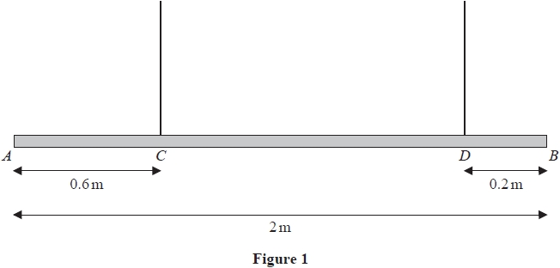

Figure 1 shows a beam *AB*, of mass *m* kg and length 2 m, suspended by two light vertical ropes.

The ropes are attached to the points *C* and *D* on the beam, where *AC* = 0.6 m and *DB* = 0.2 m

The beam is in equilibrium in a horizontal position.

A particle of mass *pm* kg is attached to the beam at *A* and the beam remains in equilibrium in a horizontal position.

The beam is modelled as a uniform rod.

(a)  Given that the tension in the rope attached at *C* is four times the tension in the rope attached at *D*, use the model to find the exact value of *p*.

**(7)**

The particle of mass *pm* kg at A is removed and replaced by a particle of mass *qm* kg at *A*.

The beam remains in equilibrium in a horizontal position but is now on the point of tilting.

(b)  Using the model, find the exact value of *q*

**(4)**

(c)  State how you have used the modelling assumption that the beam is uniform.

**(1)**

**(Total for question = 12 marks)**

**Q64.**

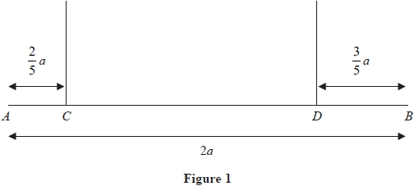

A uniform rod *AB* has length 2*a* and mass *M*. The rod is held in equilibrium in a horizontal position by two vertical light strings which are attached to the rod at *C* and *D*, where *AC* = *a* and *DB* = *a*, as shown in Figure 1.

A particle *P* is placed on the rod at *B*.

The rod remains horizontal and in equilibrium.

(a)  Find, in terms of *M*, the largest possible mass of the particle *P*

**(3)**

Given that the mass of *P* is *M*

(b)  find, in terms of *M* and *g*, the tension in the string that is attached to the rod at *C*.

**(3)**

**(Total for question = 6 marks)**

**Q65.**

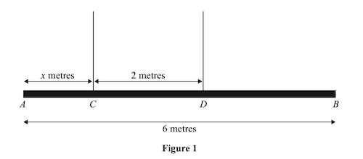

Figure 1 shows a beam *AB* with weight 24N and length 6 m.

The beam is suspended by two light vertical ropes. The ropes are attached to the points *C* and *D* on the beam where *AC* = *x* metres and *CD* = 2 m.

The tension in the rope attached to the beam at *C* is double the tension in the rope attached to the beam at *D*.

The beam is modelled as a uniform rod, resting horizontally in equilibrium.

Find

(i)  the tension in the rope attached to the beam at *D*.

(ii)  the value of *x*.

**(5)**

**(Total for question = 5 marks)**

**Q66.**

Two particles *P* and *Q* are moving in opposite directions along the same horizontal straight line. Particle *P* has mass *m* and particle *Q* has mass *km*. The particles collide directly. Immediately before the collision, the speed of *P* is *u* and the speed of *Q* is 2*u*. As a result of the collision, the direction of motion of each particle is reversed and the speed of each particle is halved.

(a)  Find the value of *k*.

**(4)**

(b)  Find, in terms of *m* and *u* only, the magnitude of the impulse exerted on *Q* by *P* in the collision.

**(2)**

**(Total for question = 6 marks)**

**Q67.**

Two particles, *P* and *Q*, have masses 2*m* and *m* respectively. The particles are moving towards each other in opposite directions along the same straight line on a smooth horizontal plane. The particles collide directly.

Immediately before the collision, the speed of *P* is 3*u* and the speed of *Q* is 2*u*.

The magnitude of the impulse exerted on *Q* by *P* in the collision is 5*mu*.

Find

(a)  the speed of *P* immediately after the collision,

**(3)**

(b)  the speed of *Q* immediately after the collision.

**(3)**

**(Total for question = 6 marks)**

**Q68.**

A particle *P* has mass 3*m* and a particle *Q* has mass 5*m*. The particles are moving towards each other in opposite directions along the same straight line on a smooth horizontal surface. The particles collide directly.

Immediately before the collision the speed of *P* is *ku*, where *k* is a constant, and the speed of *Q* is 2*u*.

Immediately after the collision the speed of *P* is *u* and the speed of *Q* is 3*u*.

The direction of motion of *Q* is reversed by the collision.

(a)  Find, in terms of *m* and *u*, the magnitude of the impulse exerted on *Q* by *P* in the collision.

**(2)**

(b)  Find the two possible values of *k*.

**(5)**

**(Total for question = 7 marks)**

**Q69.**

A particle *P* has mass *km* and a particle *Q* has mass *m*. The particles are moving towards each other in opposite directions along the same straight line when they collide directly.

Immediately before the collision, *P* has speed 3*u* and *Q* has speed *u*.

As a result of the collision, the direction of motion of each particle is reversed and the speed of each particle is halved.

(a)  Find the value of *k*.

**(4)**

(b)  Find, in terms of *m* and *u*, the magnitude of the impulse exerted on *Q* in the collision.

**(3)**

**(Total for question = 7 marks)**

**Q70.**

Two particles, *P* and *Q*, are moving towards each other in opposite directions along the same straight line when they collide directly. Immediately before the collision the speed of *Q* is 2*u*. The mass of *Q* is 3*m* and the magnitude of the impulse exerted by *P* on *Q* in the collision is 4*mu*.

Find

(a)  the speed of *Q* immediately after the collision,

**(3)**

(b)  the direction of motion of *Q* immediately after the collision.

**(1)**

**(Total for question = 4 marks)**

**Q71.**

A particle *A* has mass 4 kg and a particle *B* has mass 2 kg.

The particles move towards each other in opposite directions along the same straight line on a smooth horizontal table and collide directly.

Immediately before the collision, the speed of *A* is 2*u* m s-1 and the speed of *B* is 3*u* m s-1

Immediately after the collision, the speed of *B* is 2*u* m s-1

The direction of motion of *B* is reversed by the collision.

(a)  Find, in terms of *u*, the speed of *A* immediately after the collision.

**(3)**

(b)  State the direction of motion of *A* immediately after the collision.

**(1)**

(c)  Find, in terms of *u*, the magnitude of the impulse received by *B* in the collision. State the units of your answer.

**(3)**

**(Total for question = 7 marks)**

**Q72.**

A hammer is used to hit a tent peg into soft ground.

The hammer has mass 1.8 kg and the tent peg has mass 0.2 kg.

The hammer and tent peg are both modelled as particles and the impact is modelled as a direct collision.

Immediately before the impact, the tent peg is stationary and the hammer is moving vertically downwards with   
speed 10 m s−1

Immediately after the impact, the hammer and tent peg move together, vertically downwards, with the **same** speed *v* m s−1

(a)  Find the value of *v*

**(2)**

(b)  Find the magnitude of the impulse exerted on the tent peg by the hammer, stating the units of your answer.

**(3)**

The ground exerts a constant vertical resistive force of magnitude *R* newtons, bringing the hammer and tent peg to rest after they travel a distance of 12 cm.

(c)  Find the value of *R*.

**(5)**

**(Total for question = 10 marks)**

**Q73.**

A particle *P* of mass 0.7 kg is moving in a straight line on a smooth horizontal surface. The particle *P* collides with a particle *Q* of mass 1.2 kg which is at rest on the surface. Immediately before the collision the speed of *P* is 6 m s−1. Immediately after the collision both particles are moving in the same direction. The coefficient of restitution between the particles is *e*.

(a)  Show that 

**(7)**

Given that 

(b)  find the magnitude of the impulse exerted on *Q* in the collision.

**(3)**

**(Total for question = 10 marks)**

**Q74.**

A particle *P* of mass 2*m* is moving on a rough horizontal plane when it collides directly with a particle *Q* of mass 4*m* which is at rest on the plane. The speed of *P* immediately before the collision is 3*u*. The speed of *Q* immediately after the collision is 2*u*.

(a)  Find, in terms of *u*, the speed of *P* immediately after the collision.

**(3)**

(b)  State clearly the direction of motion of *P* immediately after the collision.

**(1)**

Following the collision, *Q* comes to rest after travelling a distance  along the plane.

The coefficient of friction between *Q* and the plane is *μ*.

(c)  Find the value of *μ*.

**(6)**

**(Total for question = 10 marks)**

**Q75.**

A railway truck *S* of mass 20 tonnes is moving along a straight horizontal track when it collides with another railway truck *T* of mass 30 tonnes which is at rest. Immediately before the collision the speed of *S* is 4 m s–1

As a result of the collision, the two railway trucks join together.

Find

(a)  the common speed of the railway trucks immediately after the collision,

**(2)**

(b)  the magnitude of the impulse exerted on *S* in the collision, stating the units of your answer.

**(3)**

**(Total for question = 5 marks)**

**Q76.**

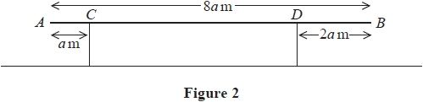

A non-uniform beam *AB*, of mass 60 kg and length 8*a* metres, rests in equilibrium in a horizontal position on two vertical supports. One support is at *C*, where *AC* = *a* metres and the other support is at *D*, where *DB* = 2*a* metres, as shown in Figure 2.

The magnitude of the normal reaction between the beam and the support at *D* is three times the magnitude of the normal reaction between the beam and the support at *C*.

By modelling the beam as a non-uniform rod whose centre of mass is at a distance *x* metres from *A*,

(a)  find an expression for *x* in terms of *a*.

**(5)**

A box of mass *M* kg is placed on the beam at *E*, where *AE* = 2*a* metres.

The beam remains in equilibrium in a horizontal position.

The magnitude of the normal reaction between the beam and the support at *C* is now equal to the magnitude of the normal reaction between the beam and the support at *D*.

By modelling the box as a particle,

(b)  find the value of *M*.

**(5)**

**(Total for question = 10 marks)**

**Q77.**

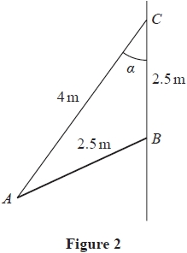

A pole *AB* has length 2.5 m and weight 70 N.   
The pole rests with end *B* against a rough vertical wall. One end of a cable of length 4 m is attached to the pole at *A*. The other end of the cable is attached to the wall at the point *C*.   
The point *C* is vertically above *B* and *BC* = 2.5 m.   
The angle between the cable and the wall is *α*, as shown in Figure 2.   
The pole is in a vertical plane perpendicular to the wall.   
The cable is modelled as a light inextensible string and the pole is modelled as a uniform rod.

Given that tan *α* = 

(a)  show that the tension in the cable is 56 N.

**(4)**

Given also that the pole is in limiting equilibrium,

(b)  find the coefficient of friction between the pole and the wall.

**(6)**

**(Total for question = 10 marks)**

**Q78.**

A car of mass 900 kg is moving down a straight road which is inclined at an angle *α* to the horizontal, where sin *α* = 

The engine of the car is working at a constant rate of 15 kW.

The resistance to the motion of the car is modelled as a constant force of magnitude 400 N.

Find the acceleration of the car at the instant when it is moving at 16 m s–1

**(5)**

**(Total for question = 5 marks)**

**Q79.**

A car of mass 600 kg travels along a straight horizontal road with the engine of the car working at a constant rate of *P* watts. The resistance to the motion of the car is modelled as a constant force of magnitude *R* newtons. At the instant when the speed of the car is 15 m s–1, the magnitude of the acceleration of the car is 0.2 m s–2.

Later the same car travels up a straight road inclined at angle *θ* to the horizontal, where sin *θ* = . The resistance to the motion of the car from non-gravitational forces is modelled as a constant force of magnitude *R* newtons. When the engine of the car is working at a constant rate of *P* watts, the car has a constant speed of 10 m s–1.

Find the value of *P*.

**(Total for question = 8 marks)**

**Q80.**

A motorcyclist and his motorcycle have a combined mass of 480 kg.

The motorcyclist drives down a straight road that is inclined at an angle *θ* to the horizontal, where sin *θ* =  , with the engine of the motorcycle working at 3.5 kW. The motorcycle is moving at a constant speed of *V* ms–1. The resistance to the motion of the motorcycle is modelled as a constant force with magnitude 20*V* newtons.

Find the value of *V*.

**(Total for question = 5 marks)**

**Q81.**

A vehicle of mass 450 kg is moving on a straight road that is inclined at angle *θ* to the horizontal, where sin *θ* = 

At the instant when the vehicle is moving **down** the road at 12 m s–1

• the engine of the vehicle is working at a rate of *P* watts  
• the **acceleration** of the vehicle is 0.5 m s–2  
• the resistance to the motion of the vehicle is modelled as a constant force of magnitude *R* newtons

At the instant when the vehicle is moving **up** the road at 12 m s–1

• the engine of the vehicle is working at a rate of 2*P* watts  
• the **deceleration** of the vehicle is 0.5 m s–2  
• the resistance to the motion of the vehicle from non-gravitational forces is modelled as a constant force of magnitude *R* newtons

Find the value of *P*.

**(8)**

**(Total for question = 8 marks)**

**Q82.**

A truck of mass 900 kg is moving along a straight horizontal road with the engine of the truck working at a constant rate of *P* watts. The resistance to the motion of the truck is modelled as a constant force of magnitude *R* newtons.   
At the instant when the speed of the truck is 15 m s–1, the deceleration of the truck is 0.2 m s–2

Later the same truck is moving down a straight road inclined at an angle *θ* to the horizontal, where sin *θ* = . The resistance to the motion of the truck is again modelled as a constant force of magnitude *R* newtons. The engine of the truck is again working at a constant rate of *P* watts.   
At the instant when the speed of the truck is 12 m s–1, the acceleration of the truck is 0.4 m s–2

Find the value of *R*.

**(Total for question = 8 marks)**

**Q83.**

A van of mass 900 kg is moving along a straight horizontal road.

The resistance to the motion of the van is modelled as a constant force of magnitude 600 N.

The engine of the van is working at a constant rate of 24 kW.

At the instant when the speed of the van is *V* ms-1, the acceleration of the van is 2 ms-2

(a)  Find the value of *V*

**(4)**

Later on, the van is towing a trailer of mass 700 kg up a straight road inclined at an angle θ to the horizontal, where 

The trailer is attached to the van by a towbar, as shown in Figure 3.

The towbar is parallel to the direction of motion of the van and the trailer.

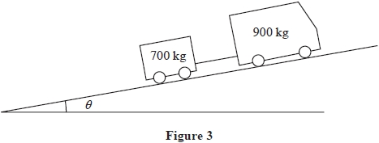

The resistance to the motion of the van from non-gravitational forces is modelled as a constant force of magnitude 600 N.

The resistance to the motion of the trailer from non-gravitational forces is modelled as a constant force of magnitude 550 N.

The towbar is modelled as a light rod.

The engine of the van is working at a constant rate of 24 kW.

(b)  Find the acceleration of the van at the instant when the van and the trailer are moving with speed 8 ms-1

**(4)**

At the instant when the van and the trailer are moving up the road at 9 ms-1, the towbar breaks. The trailer continues to move in a straight line up the road until it comes to instantaneous rest.

The distance moved by the trailer as it slows from a speed of 9 ms-1 ,to instantaneous rest is *d* metres.

(c)  Use the work-energy principle to find the value of *d*.

**(4)**

**(Total for question = 12 marks)**

**Q84.**

A car of mass 600 kg tows a trailer of mass 200 kg up a hill along a straight road that is inclined at angle *θ* to the horizontal, where . The trailer is attached to the car by a light inextensible towbar. The resistance to the motion of the car from non-gravitational forces is modelled as a constant force of magnitude 150 N. The resistance to the motion of the trailer from non-gravitational forces is modelled as a constant force of magnitude 300 N.

When the engine of the car is working at a constant rate of *P*kW the car and the trailer have a constant speed of 15 m s−1

(a)  Find the value of *P*.

**(5)**

Later, at the instant when the car and the trailer are travelling up the hill with a speed of 20 m s−1, the towbar breaks. When the towbar breaks the trailer is at the point *X*. The trailer continues to travel up the hill before coming to instantaneous rest at the point *Y*. The resistance to the motion of the trailer from non-gravitational forces is again modelled as a constant force of magnitude 300 N.

(b)  Use the work-energy principle to find the distance *XY*.

**(4)**

**(Total for question = 9 marks)**

**Q85.**

At time *t* = 0, a particle *P* is at the origin *O*, moving with speed 8 m s−1 in the positive *x* direction. At time *t* seconds, *t* ≥ 0, the acceleration of *P* has magnitude  and is directed towards *O*.

(a)  Show that, at time *t* seconds, the velocity of *P* is 

**(5)**

(b)  Find the distance of *P* from *O* when *P* comes to instantaneous rest.

**(7)**

**(Total for question = 12 marks)**

**Q86.**

A particle *P* of mass *m* is at a distance *x* above the surface of the Earth. The Earth exerts a gravitational force on *P*. This force is directed towards the centre of the Earth. The magnitude of this force is inversely proportional to the square of the distance of *P* from the centre of the Earth.

At the surface of the Earth the acceleration due to gravity is *g*.

The Earth is modelled as a fixed sphere of radius *R*.

(a)  Show that the magnitude of the gravitational force on *P* is 

**(3)**

A particle is released from rest from a point above the surface of the Earth. When the particle is at a distance *R* above the surface of the Earth, the particle has speed *U*.

Air resistance is modelled as being negligible.

(b)  Find, in terms of *U*, *g* and *R*, the speed of the particle when it strikes the surface of the Earth.

**(7)**

**(Total for question = 10 marks)**

**Q87.**

A particle *P* of mass 0.5 kg moves on the *x*-axis under the action of a single force.

At time *t* seconds, *t* ≥ 0

• *OP* = *x* metres, 0 ≤ *x* <   
• the force has magnitude sin 2*x* N and is directed towards the origin *O*  
• *P* is moving in the positive *x* direction with speed *v* m s–1

At time *t* = 0, *P* passes through the origin with speed 2 ms–1

(a)  Show that *v* = 2 cos *x*

**(6)**

(b)  Show that *t* =  when *x* = 

**(5)**

**(Total for question = 11 marks)**

**Q88.**

**In this question solutions relying on calculator technology are not acceptable.**

A particle *P* of mass 2 kg is moving along the positive *x*-axis.

At time *t* seconds, where *t* ≥ 0, *P* is *x* metres from the origin *O* and is moving away from *O* with speed *v* m s−1 where *v* = 

(a)  Find the magnitude of the resultant force acting on *P* when its speed is  m s−1

**(6)**

When *t* = 0 , *P* is at *O*

(b)  Find the value of *t* when *P* is 7.5 m from *O*

**(5)**

**(Total for question = 11 marks)**

**Q89.**

The centre of the Earth is the point *O* and the Earth is modelled as a fixed sphere of radius *R*.

At time *t* = 0, a particle *P* is projected vertically upwards with speed *U* from a point *A* on the surface of the Earth.

At time *t* seconds, where *t* ≥ 0

• *P* is a distance *x* from *O*  
• *P* is moving with speed *v*  
• *P* has acceleration of magnitude  directed towards *O*

Air resistance is modelled as being negligible.

(a)  Show that 

**(6)**

Particle *P* is first moving with speed  at the point *B*.

(b)  Given that  find, in terms of *R*, the distance *AB*.

**(3)**

(c)  Find, in terms of *g* and *R*, the smallest value of *U* that would ensure that *P* never comes to rest, explaining your reasoning.

**(3)**

**(Total for question = 12 marks)**

**Q90.**

A spacecraft *S* of mass *m* moves in a straight line towards the centre of the Earth. The Earth is modelled as a sphere of radius *R* and *S* is modelled as a particle. When *S* is at a distance *x*, *x* ≥ *R*, from the centre of the Earth, the force exerted by the Earth on *S* is directed towards the centre of the Earth. The force has magnitude , where *K* is a constant.

(a)  Show that *K* = *mgR*2

**(2)**

When *S* is at a distance 3*R* from the centre of the Earth, the speed of *S* is *V*. Assuming that air resistance can be ignored,

(b)  find, in terms of *g*, *R* and *V*, the speed of *S* as it hits the surface of the Earth.

**(7)**

**(Total for question = 9 marks)**

**Q91.**

At time *t* seconds (*t* ≥ 0) a particle *P* has velocity **v** m s−1, where

**v** = (6*t*2 + 6*t*)**i** + (3*t*2 + 24)**j**

When *t* = 0 the particle *P* is at the origin *O*. At time *T* seconds, *P* is at the point *A* and **v** = *λ*(**i** + **j**), where *λ* is a constant.

Find

(a)  the value of *T*,

**(3)**

(b)  the acceleration of *P* as it passes through the point *A*,

**(3)**

(c)  the distance *OA*.

**(5)**

**(Total for question = 11 marks)**

**Q92.**

A particle *P* of mass 1.5 kg moves under the action of a single force **F** newtons.

At time *t* seconds, *t* ≥ 0, *P* has velocity **v** ms–1, where

**v** = (5*t*2 – *t*3)**i** + (2*t*3 – 8*t*)**j**

(a)  Find **F** when *t* = 2

**(4)**

At time *t* = 0, *P* is at the origin *O*.

(b)  Find the position vector of *P* relative to *O* at the instant when *P* is moving in the direction of the vector **j**

**(4)**

**(Total for question = 8 marks)**

**Q93.**

[*In this question*  **i**  *and*  **j**  *are horizontal unit vectors directed due east and due north respectively*.]

A particle *P* moves with constant acceleration (–*λ***i** + 2*λ***j**) m s−2, where *λ* is a positive constant.

At time *t* = 0, the velocity of *P* is (5**i** − 8**j**) m s−1

(a)  Find the velocity of *P* when *t* = 5 s, giving your answer in terms of **i**, **j** and *λ*.

**(2)**

The speed of *P* when *t* = 5 s is 13 m s−1

(b)  Show that

25*λ*2 – 42*λ* − 16 = 0

**(3)**

(c)  Find the direction of motion of *P* when *t* = 4 s, giving your answer as a bearing to the nearest degree.

**(5)**

**(Total for question = 10 marks)**

**Q94.**

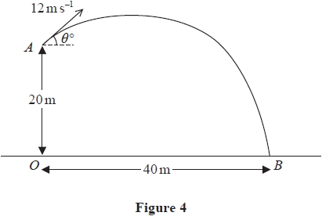

The fixed point *A* is 20 m vertically above the point *O* which is on horizontal ground. At time *t* = 0, a particle *P* is projected from *A* with speed 12 m s–1 at an angle *θ*° above the horizontal. The particle moves freely under gravity. At time *t* = 5 seconds, *P* strikes the ground at the point *B*, where *OB* = 40 m, as shown in Figure 4.

(a)  By considering energy, find the speed of *P* as it hits the ground at *B*.

**(4)**

(b)  Find the least speed of *P* as it moves from *A* to *B*.

**(2)**

(c)  Find the length of time for which the speed of *P* is more than 10 m s–1.

**(6)**

**(Total for question = 12 marks)**

**Q95.**

[*In this question, the unit vectors***i***and***j***are in a vertical plane,***i***being horizontal and***j***being vertically upwards.*]

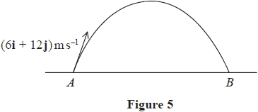

A small ball is projected with velocity (6**i** + 12**j**) ms–1 from a fixed point *A* on horizontal ground. The ball hits the ground at the point *B*, as shown in Figure 5. The motion of the ball is modelled as a particle moving freely under gravity.

(a)  Find the distance *AB*.

**(4)**

When the height of the ball above the ground is more than *h* metres, the speed of the ball is less than 10 ms–1

(b)  Find the smallest possible value of *h*.

**(4)**

When the ball is at the point *C* on its path, the direction of motion of the ball is perpendicular to the direction of motion of the ball at the instant before it hits the ground at *B*.

(c)  Find, in terms of **i** and **j**, the velocity of the ball when it is at *C*.

**(3)**

**(Total for question = 11 marks)**

**Q96.**

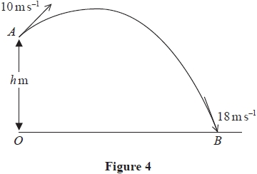

The fixed point *A* is *h* metres vertically above the point *O* that is on horizontal ground. At time *t* = 0, a particle *P* is projected from *A* with speed 10 m s–1. The particle moves freely under gravity. At time *t* = 2.5 seconds, *P* strikes the ground at the point *B*. At the instant when *P* strikes the ground, the speed of *P* is 18 m s–1, as shown in Figure 4.

(a)  By considering energy, find the value of *h*.

**(3)**

(b)  Find the distance *OB*.

**(5)**

As *P* moves from *A* to *B*, the speed of *P* is less than or equal to 8 m s–1 for *T* seconds.

(c)  Find the value of *T*

**(6)**

**(Total for question = 14 marks)**

**Q97.**

A particle *P* is projected from a fixed point *O* on horizontal ground. The particle is projected with speed *u* at an angle *α* above the horizontal. At the instant when the horizontal distance of *P* from *O* is *x*, the vertical distance of *P* above the ground is *y*.   
The motion of *P* is modelled as that of a particle moving freely under gravity.

(a)  Show that *y* = *x* tan *α* − 

**(6)**

A small ball is projected from the fixed point *O* on horizontal ground. The ball is projected with speed 20m s−1 at angle *θ°* above the horizontal. A vertical pole *AB*, of height 2m, stands on the ground with *OA* = 10 m, as shown in Figure 3.

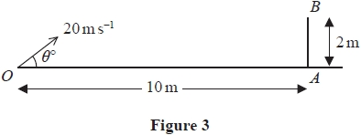

The ball is modelled as a particle moving freely under gravity and the pole is modelled as a rod.   
The path of the ball lies in the vertical plane containing *O*, *A* and *B*.

Using the model,

(b)  find the range of values of *θ* for which the ball will pass over the pole.

**(3)**

Given that *θ* = 40 and that the ball first hits the ground at the point *C*

(c)  find the speed of the ball at the instant it passes over the pole,

**(5)**

(d)  find the distance *OC*.

**(2)**

**(Total for question = 16 marks)**

**Q98.**

*[In this question, the perpendicular unit vectors* ***i*** *and* ***j*** *are in a vertical plane with* ***i*** *being horizontal and* ***j*** *being vertically upwards.]*

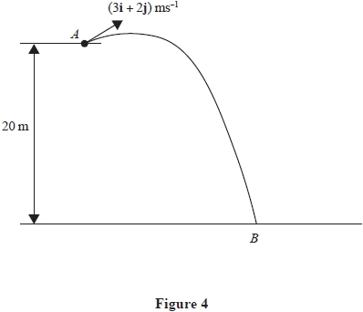

A small ball is projected with velocity (3**i** + 2**j**) ms-1 from the fixed point *A*.

The point *A* is 20 m above horizontal ground.

The ball hits the ground at the point *B*, as shown in Figure 4.

The ball is modelled as a particle moving freely under gravity.

(a)  By considering energy, find the speed of the ball at the instant immediately before it hits the ground.

**(3)**

(b)  Find the direction of motion of the ball at the instant immediately before it hits the ground.

**(3)**

(c)  Find the time taken for the ball to travel from *A* to *B*.

**(3)**

At the instant when the direction of motion of the ball is perpendicular to (3**i** + 2**j**) the ball is *h* metres above the ground.

(d)  Find the value of *h*.

**(6)**

**(Total for question = 15 marks)**

**Q99.**

[*In this question***i***and***j***are unit vectors, with***i***horizontal and***j***vertical*.]

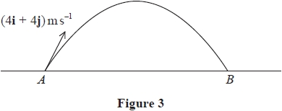

The fixed points *A* and *B* lie on horizontal ground.

At time *t* = 0, a particle *P* is projected from *A* with velocity (4**i** + 4**j**) m s−1

Particle *P* moves freely under gravity and hits the ground at *B*, as shown in Figure 3.

At time *T*1 seconds, *P* is at its highest point above the ground.

(a)  Find the value of *T*1

**(2)**

At time *t* = 0, a particle *Q* is also projected from A but with velocity (5**i** + 7**j**) m s−1

Particle *Q* moves freely under gravity.

(b)  Find the vertical distance between *Q* and *P* at time *T*1 seconds, giving your answer to 2 significant figures.

**(3)**

At the instant when particle *P* reaches *B*, particle *Q* is moving at *α*° below the horizontal.

(c)  Find the value of *α*.

**(4)**

At time *T*2 seconds, the direction of motion of *Q* is perpendicular to the initial direction of motion of *Q*.

(d)  Find the value of *T*2

**(3)**

**(Total for question = 12 marks)**

**Q100.**

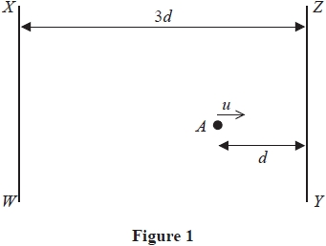

The point *A* lies on a smooth horizontal floor between two fixed smooth parallel vertical walls *WX* and *YZ*, as shown in the plan view in Figure 1.   
The distance between *WX* and *YZ* is 3*d*.   
The distance of *A* from *YZ* is *d*.   
A particle is projected from *A* along the floor with speed *u* towards *YZ* in a direction perpendicular to *YZ*.

The coefficient of restitution between the particle and each wall is 

The time taken for the particle to move from *A*, bounce off each wall once and return to *A* for the **first** time is *T*1

(a)  Find *T*1 in terms of *d* and *u*.

**(5)**

The ball returns to *A* for the first time after bouncing off each wall once.   
The further time taken for the particle to move from *A*, bounce off each wall once and return to *A* for the **second** time is *T*2

(b)  Find *T*2 in terms of *d* and *u*.

**(1)**

**(Total for question = 6 marks)**

**Q101.**

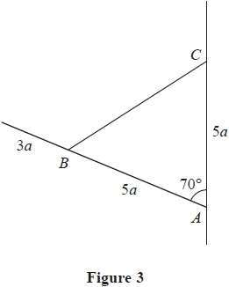

A uniform rod, of length 8*a* and mass *M*, has one end freely hinged to a fixed point *A* on a vertical wall. One end of a light inextensible string is attached to the rod at the point *B*, where *AB* = 5*a*. The other end of the string is attached to the wall at the point *C*, where *AC* = 5*a* and *C* is vertically above *A*. The rod rests in equilibrium in a vertical plane perpendicular to the wall with angle *BAC* = 70°, as shown in Figure 3.

(a)  Find, in terms of *M* and *g*, the tension in the string.

**(3)**

The magnitude of the force acting on the rod at *A* is *λMg*, where *λ* is a constant.

(b)  Find, to 2 significant figures, the value of *λ*.

**(6)**

**(Total for question = 9 marks)**

**Q102.**

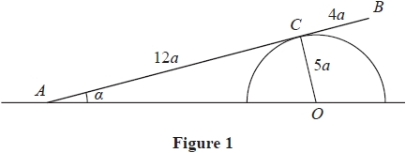

A smooth solid hemisphere is fixed with its flat surface in contact with rough horizontal ground. The hemisphere has centre *O* and radius 5*a*.   
A uniform rod *AB*, of length 16*a* and weight *W*, rests in equilibrium on the hemisphere with end *A* on the ground. The rod rests on the hemisphere at the point *C*, where *AC* = 12*a* and angle *CAO* = *α*, as shown in Figure 1.

Points *A*, *C*, *B* and *O* all lie in the same vertical plane.

(a)  Explain why *AO* = 13*a*

**(1)**

The normal reaction on the rod at *C* has magnitude *kW*

(b)  Show that 

**(3)**

The resultant force acting on the rod at *A* has magnitude *R* and acts upwards at *θ*° to the horizontal.

(c)  Find

(i)  an expression for *R* in terms of *W*

(ii)  the value of *θ*

**(8)**

**(Total for question = 12 marks)**

**Q103.**

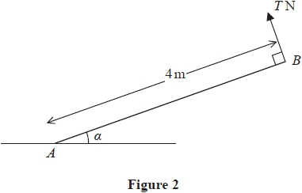

A uniform rod *AB* has length 4 m and weight 50 N.   
The rod has its end *A* on rough horizontal ground. The rod is held in equilibrium at an angle *α* to the ground by a light inextensible cable attached to the rod at *B*, as shown in Figure 2. The cable and the rod lie in the same vertical plane and the cable is perpendicular to the rod. The tension in the cable is *T* newtons.

Given that sin *α* = 

(a)  show that *T* = 20

**(3)**

Given also that the rod is in limiting equilibrium,

(b)  find the value of the coefficient of friction between the rod and the ground.

**(6)**

**(Total for question = 9 marks)**

**Q104.**

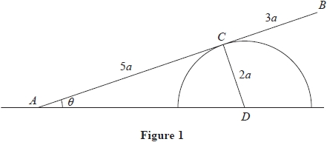

A uniform rod *AB* has length 8*a* and weight *W*.

The end *A* of the rod is freely hinged to horizontal ground.

The rod rests in equilibrium against a block which is also fixed to the ground.

The block is modelled as a smooth solid hemisphere with radius 2*a* and centre *D*.

The point of contact between the rod and the block is *C*, where *AC* = 5*a*

The rod is at an angle *θ* to the ground, as shown in Figure 1.

Points *A*, *B*, *C* and *D* all lie in the same vertical plane.

(a)  Show that *AD* = 

**(1)**

(b)  Show that the magnitude of the normal reaction at *C* between the rod and the block is 

**(3)**

The resultant force acting on the rod at *A* has magnitude *kW* and acts at an angle *α* to the ground.

(c)  Find (i)  the exact value of *k*

(ii)  the exact value of tan *α*

**(8)**

**(Total for question = 12 marks)**

**Q105.**

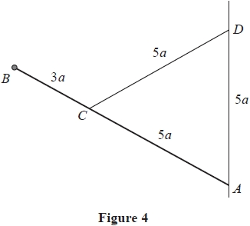

A uniform rod *AB* has length 8*a* and weight *W*.

The end *A* of the rod is freely hinged to a fixed point on a vertical wall.

A particle of weight *W* is attached to the rod at *B*.

A light inelastic string of length 5*a* has one end attached to the rod at the point *C*, where *AC* = 5*a*.

The other end of the string is attached to the wall at the point *D*, where *D* is above *A* and *AD* = 5*a*, as shown in Figure 4.

The rod rests in equilibrium.

The tension in the string is *T*.

(a)  Show that 

**(3)**

(b)  Find, in terms of *W*, the magnitude of the force exerted on the rod by the hinge at *A*.

**(6)**

**(Total for question = 9 marks)**

**Q106.**

A fixed rough plane is inclined at an angle *θ* to the horizontal, where tan *θ* = 

A particle of mass 6 kg is projected with speed 5 ms –1 from a point *A* on the plane, up a line of greatest slope of the plane.

The coefficient of friction between the particle and the plane is 

(a)  Find the magnitude of the frictional force acting on the particle as it moves up the plane.

**(3)**

The particle comes to instantaneous rest at the point *B*.

(b)  Find the distance *AB*.

**(5)**

The particle now slides down the plane from *B*. At the instant when the particle passes through the point *C* on the plane, the speed of the particle is again 5 ms –1

(c)  Find the distance *BC*.

**(5)**

**(Total for question = 13 marks)**

**Q107.**

A train travels along a straight horizontal track between two stations *A* and *B*.

The train starts from rest at station *A* and accelerates uniformly for *T* seconds until it reaches a speed of 20 m s−1

The train then travels at a constant speed of 20 m s−1 for 3 minutes before decelerating uniformly until it comes to rest at station *B*.

The magnitude of the acceleration of the train is twice the magnitude of the deceleration.

(a)  On the axes below, sketch a speed–time graph to illustrate the motion of the train as it moves from   
station *A* to station *B*.

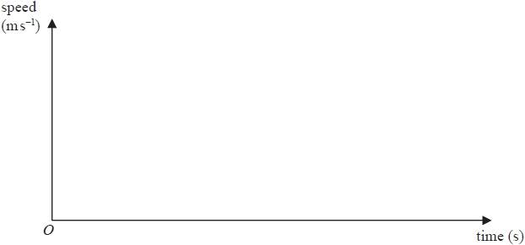

**If you need to redraw your graph, use the axes below**

**(3)**

Stations *A* and *B* are 4.8 km apart.

(b)  Find the value of *T*

**(5)**

(c)  Find the acceleration of the train during the first *T* seconds of its motion.

**(2)**

**(Total for question = 10 marks)**

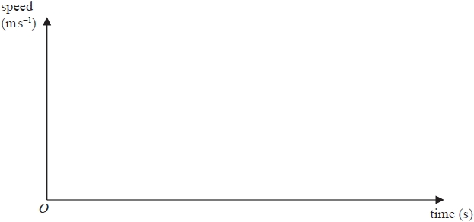

**Q108.**

Two trams, tram *A* and tram *B*, run on parallel straight horizontal tracks. Initially the two trams are at rest in the depot and level with each other.

At time *t* = 0, tram *A* starts to move. Tram *A* moves with constant acceleration 2 ms –2 for 5 seconds and then continues to move along the track at constant speed.

At time *t* = 20 seconds, tram *B* starts from rest and moves in the same direction as tram *A*. Tram *B* moves with constant acceleration 3 ms –2 for 4 seconds and then continues to move along the track at constant speed.

The trams are modelled as particles.

(a)  Sketch, on the same axes, a speed-time graph for the motion of tram *A* and a speed-time graph for the motion of tram *B*, from *t* = 0 to the instant when tram *B* overtakes tram *A*.

**(3)**

At the instant when the two trams are moving with the same speed, tram *A* is *d* metres in front of tram *B*.

(b)  Find the value of *d*.

**(5)**

(c)  Find the distance of the trams from the depot at the instant when tram *B* overtakes tram *A*.

**(5)**

**(Total for question = 13 marks)**

**Q109.**

Unless otherwise indicated, whenever a numerical value of *g* is required, take *g* = 9.8 m s−2 and give your answer to either 2 significant figures or 3 significant figures.

A car is moving along a straight horizontal road with constant acceleration a m s−2 (*a* > 0). At time *t* = 0 the car passes the point *P* moving with speed *u* m s−1. In the next 4 s, the car travels 76 m and then in the following 6 *s* it travels a further 219 m.

Find

(i)  the value of *u*,

(ii)  the value of *a*.

**(Total for question = 7 marks)**

**Q110.**

A small stone is projected vertically upwards with speed 20 m s–1 from a point *O* which is 5 m above horizontal ground. The stone is modelled as a particle moving freely under gravity.

Find

(a)  the speed of the stone at the instant when it is 2 m above the ground,

**(2)**

(b)  the total time between the instant when the stone is projected from *O* and the instant when it first strikes the ground.

**(4)**

**(Total for question = 6 marks)**

**Q111.**

A helicopter is hovering at rest above horizontal ground at the point *H*. A parachutist steps out of the helicopter and immediately falls vertically and freely under gravity from rest for 2.5 s. His parachute then opens and causes him to immediately decelerate at a constant rate of 3.9 m s–2 for *T* seconds (*T* < 6), until his speed is reduced to *V* m s–1. He then moves with this constant speed *V* m s–1 until he hits the ground. While he is decelerating, he falls a distance of 73.75 m. The total time between the instant when he leaves *H* and the instant when he hits the ground is 20 s.

The parachutist is modelled as a particle.

(a)  Find the speed of the parachutist at the instant when his parachute opens.

**(1)**

(b)  Sketch a speed-time graph for the motion of the parachutist from the instant when he leaves *H* to the instant when he   
hits the ground.

**(2)**

(c)  Find the value of *T*.

**(5)**

(d)  Find, to the nearest metre, the height of the point *H* above the ground.

**(4)**

**(Total for question = 12 marks)**

**Q112.**

A car is moving at a constant speed of 25 m s–1 along a straight horizontal road.

The car is modelled as a particle.

At time *t* = 0, the car is at the point *A* and the driver sees a road sign 48 m ahead.

Let *t* seconds be the time that elapses after the car passes *A*.

In a **first** model, the car is assumed to decelerate uniformly at 6 m s–2 from *A* until the car reaches the road sign.

(a)  Use this first model to find the speed of the car as it reaches the sign.

**(2)**

The road sign indicates that the speed limit immediately after the sign is 13 m s–1.

In a **second** model, the car is assumed to decelerate uniformly at 6 m s–2 from *A* until it reaches a speed of 13 m s–1. The car then maintains this speed until it reaches the road sign.

(b)  Use this second model to find the value of *t* at which the car reaches the sign.

**(4)**

In a **third** model, the car is assumed to move with constant speed 25 m s–1 from A until time *t* = 0.2, the car then decelerates uniformly at 6 m s–2 until it reaches a speed of 13 m s–1. The car then maintains this speed until it reaches the road sign.

(c)  Use this third model to find the value of *t* at which the car reaches the sign.

**(4)**

**(Total for question = 10 marks)**

**Q113.**

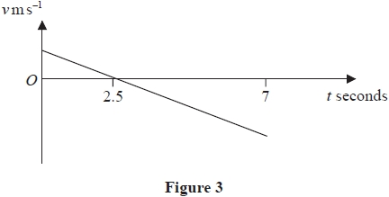

A small ball is thrown vertically upwards at time *t* = 0 from a point *A* which is above horizontal ground. The ball hits the ground 7 s later.

The ball is modelled as a particle moving freely under gravity.

The velocity-time graph shown in Figure 3 represents the motion of the ball for 0 ≤ *t* ≤ 7

(a)  Find the speed with which the ball is thrown.

**(2)**

(b)  Find the height of *A* above the ground.

**(3)**

**(Total for question = 5 marks)**

**Q114.**

A motorbike is moving with constant acceleration along a straight horizontal road.

The motorbike passes a point *P* and 10 seconds later passes a point *Q*.

The speed of the motorbike as it passes *Q* is 28 m s–1

Given that *PQ* = 220 m,

(a)  find the acceleration of the motorbike,

**(3)**

(b)  find the distance travelled by the motorbike during the fifth second after passing *P*

**(4)**

**(Total for question = 7 marks)**

**Q115.**

Two students observe a book of mass 0.2 kg fall vertically from rest from a shelf that is 1.5 m above the floor.

Student *A* suggests that the book is modelled as a particle falling freely under gravity.

(a)  Use student *A*'s model to find the time taken for the book to reach the floor.

**(3)**

Student *B* suggests an improved model where the book is modelled as a particle experiencing a constant resistance to motion of magnitude *R* newtons.

Given that the time taken for the book to reach the floor is 0.6 seconds,

(b)  use student *B*'s model to find the value of *R*

**(5)**

**(Total for question = 8 marks)**

**Q116.**

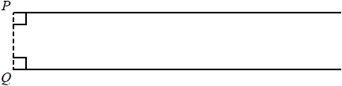

**Figure 2**

Two cars, *A* and *B*, move on parallel straight horizontal tracks. Initially *A* and *B* are both at rest with A at the point *P* and *B* at the point *Q*, as shown in Figure 2. At time *t* = 0 seconds, A starts to move with constant acceleration a m s−2 for 3.5 s, reaching a speed of 14 m s−1. Car A then moves with constant speed 14 m s−1.

(a)  Find the value of *a*.

**(2)**

Car *B* also starts to move at time *t* = 0 seconds, in the same direction as car *A*. Car *B* moves with a constant acceleration of 3 m s−2. At time *t* = *T* seconds, *B* overtakes *A*. At this instant *A* is moving with constant speed.

(b)  On a diagram, sketch, on the same axes, a speed-time graph for the motion of *A* for the interval 0 ≤ *t* ≤ *T* and a speed-time graph for the motion of *B* for the interval 0 ≤ *t* ≤ *T*.

**(3)**

(c)  Find the value of *T*.

**(8)**

(d)  Find the distance of car *B* from the point *Q* when *B* overtakes *A*.

**(1)**

(e)  On a new diagram, sketch, on the same axes, an acceleration-time graph for the motion of *A* for the interval 0 ≤ *t* ≤ *T* and an acceleration-time graph for the motion of *B* for the interval 0 ≤ *t* ≤ *T*.

**(3)**

**(Total for question = 17 marks)**

**Q117.**

A block *A* of mass 9 kg is released from rest from a point *P* which is a height *h* metres above horizontal soft ground. The block falls and strikes another block *B* of mass 1.5 kg which is on the ground vertically below *P*. The speed of *A* immediately before it strikes *B* is 7 m s−1. The blocks are modelled as particles.

(a)  Find the value of *h*.

**(2)**

Immediately after the impact the blocks move downwards together with the same speed and both come to rest after sinking a vertical distance of 12 cm into the ground. Assuming that the resistance offered by the ground has constant magnitude *R* newtons,

(b)  find the value of *R*.

**(8)**

**(Total for question = 10 marks)**

**Q118.**

At time *t* = 0, a small ball is projected vertically upwards from a point *A* which is 24.5 m above the ground. The ball first comes to instantaneous rest at the point *B*, where *AB* = 19.6 m and first hits the ground at time *t* = *T* seconds.

The ball is modelled as a particle moving freely under gravity.

(a)  Find the value of *T*.

**(6)**

(b)  Sketch a speed-time graph for the motion of the ball from *t* = 0 to *t* = *T* seconds.

(No further calculations are needed in order to draw this sketch.)

**(2)**

**(Total for question = 8 marks)**

**Q119.**

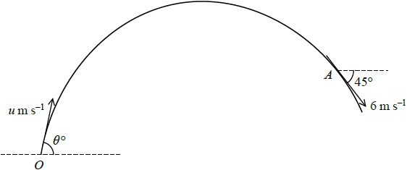

**Figure 4**

At time *t* = 0, a particle *P* of mass 0.7 kg is projected with speed *u* m s−1 from a fixed point *O* at an angle *θ*° to the horizontal. The particle moves freely under gravity. At time *t* = 2 seconds, *P* passes through the point *A* with speed 6 m s−1 and is moving downwards at 45° to the horizontal, as shown in Figure 4.

Find

(a)  the value of *θ*,

**(6)**

(b)  the kinetic energy of *P* as it reaches the highest point of its path.

**(3)**

For an interval of *T* seconds, the speed, *v* m s−1, of *P* is such that *v* ≤ 6

(c)  Find the value of *T*.

**(5)**

**(Total for question = 14 marks)**

**Q120.**

A small ball is projected vertically upwards with speed 29.4 m s–1 from a point A which is 19.6 m above horizontal ground.

The ball is modelled as a particle moving freely under gravity until it hits the ground. It is assumed that the ball does not rebound.

(a)  Find the distance travelled by the ball while its speed is less than 14.7 m s–1

**(3)**

(b)  Find the time for which the ball is moving with a speed of more than 29.4 m s–1

**(3)**

(c)  Sketch a speed-time graph for the motion of the ball from the instant when it is projected from *A* to the instant when it hits the ground. Show clearly where your graph meets the axes.

**(3)**

**(Total for question = 9 marks)**

**Q121.**

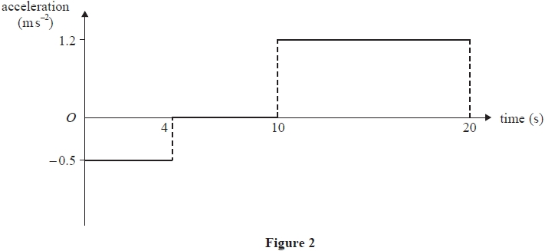

Two fixed points, *A* and *B*, are on a straight horizontal road.

The **acceleration-time** graph in Figure 2 represents the motion of a car travelling along the road as it moves from *A* to *B*.

At time *t* = 0, the car passes through *A* with speed 8 m s−1

At time *t* = 20 s, the car passes through *B* with speed *v* m s−1

(a)  Show that *v* = 18

**(3)**

(b)  Sketch a speed-time graph for the motion of the car from *A* to *B*.

**(3)**

(c)  Find the distance *AB*.

**(4)**

**(Total for question = 10 marks)**

**Q122.**

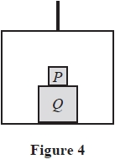

A simple lift operates by means of a vertical cable which is attached to the top of the lift.   
The lift has mass *m*  
A box *Q* is placed on the floor of the lift.   
A box *P* is placed directly on top of box *Q*, as shown in Figure 4.

The cable is modelled as being light and inextensible and air resistance is modelled as being negligible.

The tension in the cable is 

The lift and its contents move vertically upwards with acceleration 

Using the model,

(a)  find, in terms of *m*, the combined mass of boxes *P* and *Q*

**(4)**

During the motion of the lift, the force exerted on box *P* by box *Q* is 

Using the model,

(b)  find, in terms of *m*, the mass of box *P*

**(3)**

**(Total for question = 7 marks)**

**Q123.**

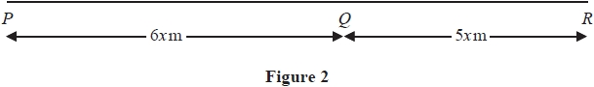

Three points *P*, *Q* and *R* are on a horizontal road where *PQR* is a straight line.

The point *Q* is between *P* and *R*, with *PQ* = 6*x* metres and *QR* = 5*x* metres, as shown in Figure 2.

A vehicle moves along the road from *P* to *Q* with constant acceleration.

The vehicle is modelled as a particle.

At time *t* = 0, the vehicle passes *P* with speed *u* m s−1

At time *t* = 12 s, the vehicle passes *Q* with speed 2*u* m s−1

Using the model,

(a)  show that *x* = 3*u*

**(2)**

As the vehicle passes *Q*, the acceleration of the vehicle changes instantaneously to 1.5 m s−2

The vehicle continues to move with a constant acceleration of 1.5 m s−2 and passes *R* with speed 3*u* ms−1

Using the model,

(b)  find the value of *u*,

**(3)**

(c)  find the distance travelled by the vehicle during the first 14 seconds after passing *P*

**(4)**

**(Total for question = 9 marks)**

**Q124.**

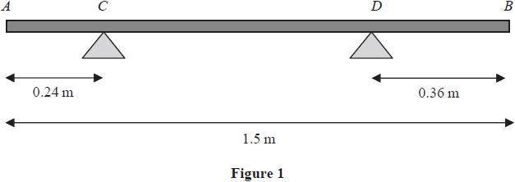

A branch *AB*, of length 1.5 m, rests horizontally in equilibrium on two supports.

The two supports are at the points *C* and *D*, where *AC* = 0.24m and *DB* = 0.36m, as shown in Figure 1.

When a force of 150 N is applied vertically upwards at *B*, the branch is on the point of tilting about *C*.

When a force of 225 N is applied vertically downwards at *B*, the branch is on the point of tilting about *D*.

The branch is modelled as a non-uniform rod *AB* of weight *W* newtons.

The distance from the point *C* to the centre of mass of the rod is *x* metres.

Use the model to find

(i)  the value of *W*

(ii)  the value of *x*

**(Total for question = 8 marks)**

**Q125.**

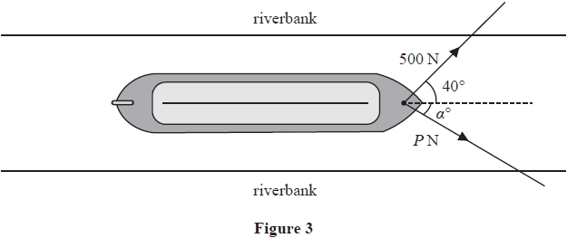

A boat is pulled along a river at a constant speed by two ropes.

The banks of the river are parallel and the boat travels horizontally in a straight line, parallel to the riverbanks.

• The tension in the first rope is 500 N acting at an angle of 40° to the direction of motion, as shown in Figure 3.  
  
• The tension in the second rope is *P* newtons, acting at an angle of *α*° to the direction of motion, also shown in Figure 3.  
  
• The resistance to motion of the boat as it moves through the water is a constant force of magnitude 900 N

The boat is modelled as a particle. The ropes are modelled as being light and lying in a horizontal plane.

Use the model to find

(i)  the value of *α*

(ii)  the value of *P*

**(Total for question = 8 marks)**

**Q126.**

A particle *P* is projected from a fixed point *O*. The particle is projected with speed *u* m s–1 at angle *α* above the horizontal. The particle moves freely under gravity. At the instant when the horizontal distance of *P* from *O* is *x* metres, *P* is *y* metres vertically above the level of *O*.

(a)  Show that 

**(6)**

A small ball is projected from a fixed point A with speed *U* m s–1 at *θ*° above the horizontal.   
The point *B* is on horizontal ground and is vertically below the point *A*, with *AB* = 20 m.   
The ball hits the ground at the point *C*, where *BC* = 30 m , as shown in Figure 4.

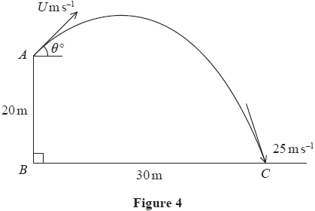

The speed of the ball immediately before it hits the ground is 25 m s–1  
The motion of the ball is modelled as that of a particle moving freely under gravity.

(b)  Use the principle of conservation of mechanical energy to find the value of *U*.

**(3)**

(c)  Find the value of *θ*

**(3)**

**(Total for question = 12 marks)**

**Q127.**

A particle *P* moves on the *x*-axis.

At time *t* = 0, *P* is instantaneously at rest at *O*.

At time t seconds, *t* > 0, the *x* coordinate of *P* is given by



Find

(a)  the non-zero values of *t* for which *P* is at instantaneous rest

**(3)**

(b)  the total distance travelled by *P* in the interval 0 ≤ *t* ≤ 4

**(3)**

(c)  the acceleration of *P* when *t* = 4

**(3)**

**(Total for question = 9 marks)**

**Q128.**

A particle *P* of mass *m* kg is initially held at rest at the point *O* on a smooth inclined plane. The plane is inclined at an angle *α* to the horizontal, where sin *α* = 

The particle is released from rest and slides down the plane against a force which acts towards *O*. The force has magnitude *mx*2N, where *x* metres is the distance of *P* from *O*.

(a)  Find the speed of *P* when *x* = 2

**(6)**

The particle first comes to instantaneous rest at the point *A*.

(b)  Find the distance *OA*.

**(2)**

**(Total for question = 8 marks)**

**Q129.**

At time *t* seconds, *t* ≥ 0, a particle *P* has position vector **r** metres with respect to a fixed origin *O*, where

**r** = (*t*3 – 8*t*)**i** + **j**

(a)  Find the acceleration of *P* when *t* = 4

**(5)**

At time *T* seconds, *T* ≥ 0, *P* is moving in the direction of (2**i** + **j**)

(b)  Find the value of *T*

**(3)**

**(Total for question = 8 marks)**

**Q130.**

**In this question you must show all stages of your working.**

**Solutions relying entirely on calculator technology are not acceptable.**

A particle *P* is moving along a straight line.

At time *t* seconds, *P* is a distance x metres from a fixed point *O* on the line and is moving away from *O* with speed  ms-1.

(a)  Find the deceleration of *P* when *x* = 12

**(5)**

Given that *x* = 4 when *t* = 1

(b)  find the value of *t* when *x* = 12

**(5)**

**(Total for question = 10 marks)**

**Q131.**

At time *t* seconds  a particle *P* has velocity **v** m s–1, where



When *t* = *λ*, particle *P* is moving in a direction parallel to the vector **i**.

(a)  Find the acceleration of *P* when *t* = *λ*

**(5)**

The position vector of *P* is measured relative to the fixed point *O*

When *t* = 1, the position vector of *P* is (–2**i** + **j**) *m*.

Given that 

(b)  find, in terms of *T*, the position vector of *P* when *t* = *T*

**(5)**

**(Total for question = 10 marks)**

**Q132.**

At time *t* seconds, *t* > 0, a particle *P* is at the point with position vector **r** m, where



(a)  Find the velocity of *P* when *P* is moving in a direction parallel to the vector **j**

**(4)**

(b)  Find the acceleration of *P* when *t* = 4

**(3)**

**(Total for question = 7 marks)**

**Q133.**

Two forces, **F**1 and **F**2, act on a particle *A*.

**F**1 = (2**i** − 3**j**) N and **F**2 = (*p***i** + *q***j**) N, where *p* and *q* are constants.

Given that the resultant of **F**1 and **F**2 is parallel to (**i** + 2**j**),

(a)  show that 2*p* − *q* + 7 = 0

**(5)**

Given that *q* = 11 and that the mass of *A* is 2 kg, and that **F**1 and **F**2 are the only forces acting on *A*,

(b)  find the magnitude of the acceleration of *A*.

**(5)**

**(Total for question = 10 marks)**

**Q134.**

[*In this question, the perpendicular unit vectors***i***and***j***are in a horizontal plane*.]

A particle *Q* of mass 1.5 kg is moving on a smooth horizontal plane under the action of a single force **F** newtons. At time *t* seconds (*t* ≥ 0) , the position vector of *Q*, relative to a fixed point *O*, is **r** metres and the velocity of *Q* is **v** m s–1

It is given that

**v** = (3*t*2 + 2*t*) **i** + (*t*3 + *kt*) **j**

where *k* is a constant.

Given that when *t* = 2 particle *Q* is moving in the direction of the vector **i** + **j**

(a)  show that *k* = 4

**(2)**

(b)  find the magnitude of **F** when *t* = 2

**(4)**

Given that **r** = 3**i** + 4**j** when *t* = 0

(c)  find **r** when *t* = 2

**(4)**

**(Total for question = 10 marks)**

**Q135.**

**In this question you must show all stages in your working.**

**Solutions relying entirely on calculator technology are not acceptable.**

A particle *P* is moving along the *x*-axis.

At time *t* seconds, where , *P* is *x* metres from the origin *O* and is moving

with velocity *v* m s−1 in the positive *x* direction where



When *t* = 0, *P* passes through *O*.

(a)  Find the value of *x* when the acceleration of *P* is 243 m s−2

**(4)**

(b)  Find *v* in terms of *t*.

**(6)**

**(Total for question = 10 marks)**

**Q136.**

A particle *P* of mass 0.25 kg is moving on a smooth horizontal surface under the action of a single force, **F** newtons.

At time *t* seconds (*t* ≥ 0), the velocity **v** m s−1 of *P* is given by

**v** = (6 sin 3*t*)**i** + (1 + 2 cos *t*)**j**

(a)  Find **F** in terms of *t*.

**(3)**

At time *t* = 0, the position vector of *P* relative to a fixed point *O* is m.

(b)  Find the position vector of *P* relative to *O* when *P* is first moving parallel to the vector **i**.

**(6)**

**(Total for question = 9 marks)**

**Q137.**

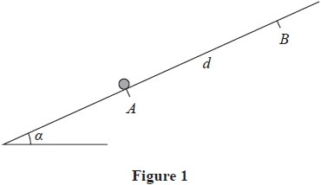

A particle of mass *m* is held at rest at a point *A* on a rough plane.

The plane is inclined at an angle *α* to the horizontal, where tan *α* = 

The coefficient of friction between the particle and the plane is 

The points *A* and *B* lie on a line of greatest slope of the plane, with *B* above *A*, and *AB* = *d*, as shown in Figure 1.

The particle is pushed up the line of greatest slope from *A* to *B*.

(a)  Show that the work done against friction as the particle moves from *A* to *B* is *mgd*

**(3)**

The particle is then held at rest at *B* and released.

(b)  Use the work-energy principle to find, in terms of *g* and *d*, the speed of the particle at the instant it reaches *A*.

**(4)**

**(Total for question = 7 marks)**

**Q138.**

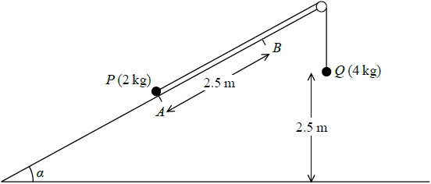

**Figure 1**

Two particles *P* and *Q*, of mass 2 kg and 4 kg respectively, are connected by a light inextensible string. Initially *P* is held at rest at the point *A* on a rough fixed plane inclined at *α* to the horizontal ground, where sin *α* = . The string passes over a small smooth pulley fixed at the top of the plane. The particle *Q* hangs freely below the pulley and 2.5 m above the ground, as shown in Figure 1. The part of the string from *P* to the pulley lies along a line of greatest slope of the plane. The system is released from rest with the string taut. At the instant when *Q* hits the ground, *P* is at the point *B* on the plane. The coefficient of friction between *P* and the plane is .

(a)  Find the work done against friction as *P* moves from *A* to *B*.

**(4)**

(b)  Find the total potential energy lost by the system as *P* moves from *A* to *B*.

**(3)**

(c)  Find, using the work-energy principle, the speed of *P* as it passes through *B*.

**(4)**

**(Total for question = 11 marks)**

**Q139.**

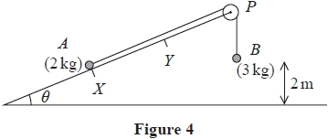

Two particles, *A* and *B*, of mass 2 kg and 3 kg respectively, are connected by a light inextensible string. Particle *A* is held at rest at the point *X* on a fixed rough ramp that is inclined at an angle *θ* to the horizontal, where tan *θ* = . The string passes over a small smooth pulley *P* that is fixed at the top of the ramp. Particle *B* hangs vertically below *P*, 2 m above the ground, as shown in Figure 4.

The particles are released from rest with the string taut so that *A* moves up the ramp and the section of the string from *A* to *P* is parallel to a line of greatest slope of the ramp.

The coefficient of friction between *A* and the ramp is 

Air resistance is ignored.

(a)  Find the potential energy lost by the system as *A* moves 2 m up the ramp.

**(3)**

(b)  Find the work done against friction as *A* moves 2 m up the ramp.

**(4)**

When *B* hits the ground, *B* is brought to rest by the impact and does not rebound and *A* continues to move up the ramp.

(c)  Use the work-energy principle to find the speed of *B* at the instant before it hits the ground.

**(4)**

Particle *A* comes to instantaneous rest at the point *Y* on the ramp, where *XY* = (2 + *d*) m.

(d)  Use the work-energy principle to find the value of *d*.

**(4)**

**(Total for question = 15 marks)**

**Q140.**

Unless otherwise indicated, whenever a numerical value of *g* is required, take *g* = 9.8 m s−2 and give your answer to either 2 significant figures or 3 significant figures.

A car of mass 900 kg is travelling up a straight road inclined at an angle *θ* to the horizontal, where sin *θ* = . The car is travelling at a constant speed of 14 m s−1 and the resistance to motion from non-gravitational forces has a constant magnitude of 800 N. The car takes 10 seconds to travel from *A* to *B*, where *A* and *B* are two points on the road.

(a)  Find the work done by the engine of the car as the car travels from *A* to *B*.

**(4)**

When the car is at *B* and travelling at a speed of 14 m s−1 the rate of working of the engine of the car is suddenly increased to *P* kW, resulting in an initial acceleration of the car of 0.7 m s−2. The resistance to motion from non-gravitational forces still has a constant magnitude of 800 N.

(b)  Find the value of *P*.

**(4)**

**(Total for question = 8 marks)**

**Q141.**

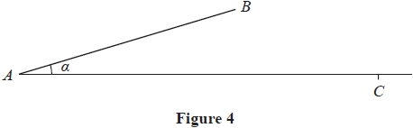

Figure 4 shows a rough ramp fixed to horizontal ground.

The ramp is inclined at angle *α* to the ground, where tan *α* = 

The point *A* is on the ground at the bottom of the ramp.   
The point *B* is at the top of the ramp.   
The line *AB* is a line of greatest slope of the ramp and *AB* = 4 m.

A particle *P* of mass 3 kg is projected with speed *U* m s–1 from *A* directly towards *B*.

The coefficient of friction between the particle and the ramp is 

(a)  Find the work done against friction as *P* moves from *A* to *B*.

**(4)**

Given that at the instant *P* reaches the point *B*, the speed of *P* is 5 m s–1

(b)  use the work-energy principle to find the value of *U*.

**(4)**

The particle leaves the ramp at *B*, and moves freely under gravity until it hits the ground at the point *C*.

(c)  Find the horizontal distance from *B* to *C*.

**(6)**

**(Total for question = 14 marks)**

**Q142.**

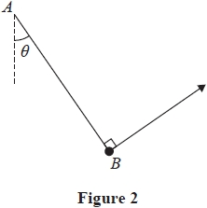

A light elastic string *AB* has modulus of elasticity 2*mg* and natural length *ka*, where *k* is a constant.

The end *A* of the elastic string is attached to a fixed point. The other end *B* is attached to a particle of mass *m*. The particle is held in equilibrium, with the elastic string taut, by a force that acts in a direction that is perpendicular to the string. The line of action of the force and the elastic string lie in the same vertical plane. The string makes an angle *θ* with the downward vertical at *A*, as shown in Figure 2.

Given that the length , find the value of *k*.

**(Total for question = 6 marks)**

**Q143.**

A cyclist is travelling on a straight horizontal road and working at a constant rate of 500 W.

The total mass of the cyclist and her cycle is 80 kg.

The total resistance to the motion of the cyclist is modelled as a constant force of magnitude 60 N.

(a)  Using this model, find the acceleration of the cyclist at the instant when her speed is 6 m s−1

**(4)**

On the following day, the cyclist travels up a straight road from a point *A* to a point *B*.

The distance from *A* to *B* is 20 km.

Point *A* is 500 m above sea level and point *B* is 800 m above sea level.

The cyclist starts from rest at *A*.

At the instant she reaches *B* her speed is 8 m s−1

The total resistance to the motion of the cyclist from non-gravitational forces is modelled as a constant force   
of magnitude 60 N.

(b)  Using this model, find the total work done by the cyclist in the journey from *A* to *B*.

**(5)**

Later on, the cyclist is travelling up a straight road which is inclined at an angle *α* to the horizontal, where 

The cyclist is now working at a constant rate of P watts and has a constant speed of 7 m s−1

The total resistance to the motion of the cyclist from non-gravitational forces is again modelled as a constant force of magnitude 60 N.

(c)  Using this model, find the value of *P*

**(4)**

**(Total for question = 13 marks)**